PHYSICO-CHEMICAL PARAMETERS OF THE MAGMA CHAMBER UNDER KIZIMEN VOLCANO (KAMCHATKA)

Sergey V. Trusov, Pavel Yu. Pletchov

Petrology Department of the Moscow State University, Russia
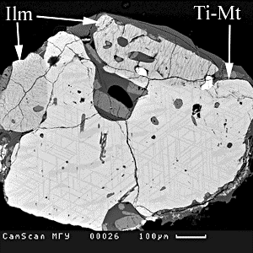
Fig.1 BSE image of Ti-Mt – Ilm intergrowth
We suggest the existence of a long-lived silicic magma chamber underneath Kizimen volcano which has periodically received an influx of basaltic magma. These basic additions heated the host magma, led to compositional mixing, and caused the appearance of progressively more basic eruptive products. The eruptive history of Kizimen volcano is divided into several large cycles of volcanic activity followed by pauses . Each period started with eruption of the rhyodacitic magma, which consequently changed to dacites, andesites, and basaltic andesites [Melekestsev et al., 1992]. For reconstruction of the conditions in the primary magmatic chamber, which are thought to be less changed by mixing processes, we have studied the rocks of the dacitic extrusion «Gorb» on the western slope of the volcano. This extrusion was formed during earliest eruptive period of the volcano [Melekestsev et al., 1992].
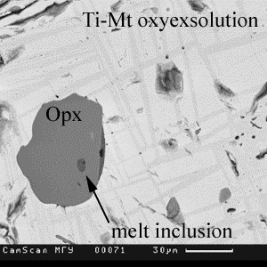
The rocks of the extrusion are presented by dacites (65 wt.% SiO₂). They are characterized by the presence of the interlayering of red and gray lobes. They are similar in composition but have different content of the spherulites (up to 40% in the red layers and 5-10% in the gray ones). The spherulites (200-400 μm) consist of plagioclase (An₅₈₋₅₇), Fe-Ti oxides, and acid glass. Dacites have porphyric structure. Phenocrysts (~30% of the rock) represented by Mg-hornblende, plagioclase, orthopyroxene, quartz, Fe-Ti oxides are embedded into acid glass (76-78% wt.% SiO₂). There are two types of plagioclase with complex zoning: Plag1 has Na-rich cores and Ca-rich rims (An₆₂₋₆₅ … An₈₆₋₈₄) and Plag2 has Ca-rich cores and Na-rich rims (An₉₁₋₈₉ … An₇₃₋₇₁). Orthopyroxene phenocrysts are restricted in composition and represented by hyperstene En₆₃₋₆₅Wo₁₋₂. Rare quartz phenocrysts are found in rocks (~ 1 % of phenocrysts). Magmatic intergrowths of Ti-magnetite (Mt_{0.81} Usp_{0.19}) and ilmenite (Ilm_{0.73} Hem_{0.27}) are observed (Pic.1). After oxidation, both phases were exsolved to form high Ti and low Ti constituents. The simultaneous growth of ilmenite and Ti-magnetite point to oxidizing conditions in the magmatic chamber was estimated by program QUIlF [Frost and Lindsley 1992] as QFM+2.3.

Fig.2. BSE image of melt inclusion in orthopyroxene

We also estimated the pressure conditions using hornblende geobarometer [Anderson and Smith, 1995] and derived a result of 1.2-1.6 Kbar or a depth of 4-6 km. Temperatures were calculated from plagioclase-amphibole equlibration [Blundy and Holland, 1990] (760-750 ^{о}С) and from magnetite-ilmenite equilibration (834-822^{о}С).

The composition of the melt was estimated from melt inclusions in the orthopyroxene (in average, wt%): SiO2 77.73, TiO2 0.21, Al2O3 12.63, FeO 1.27, MnO 0.09, MgO 0.16, CaO - 1.28, Na2O 2.78, K2O 3.40 (Pic.2). The compositions of melt inclusions and groundmass glasses of the sample, which contain phenocrysts with studied inclusions, allows us to neglect the possible mixing processes.
Therefore, the long-lived magma chamber under Kizimen volcano is filled with rhyolitic melt with phenocrysts of plagioclase, Mg-hornblende, orthopyroxene, Ti-magnetite, and ilmenite. The magma chamber was located at depths of 4-6 km. Its temperature was 750-825^{о}C. This chamber was the main source of the material of the explosive eruptions and extrusive domes of the Kizimen volcano.

References

- Melekestsev I.V., Ponomareva V.V., Volynets O.N. (1995), J. Volc. Geoth. Res., 65, 3-4, 205-226
- Anderson, J.L.; Smith, D.R. (1995) Am. Min., 80, 549-559
- Blundy J.D., Holland T.J.B. (1990) Contrib. Min. Pet. 104, 208-224
- Frost B.R., Lindsley D.H. (1992) Am. Min. 77, 1004-1020.

