POSTSEISMIC CRUSTAL DEFORMATION ASSOCIATED WITH THE 2003 TOKACHI-OKI EARTHQUAKE (M_{JMA}8.0), OFF SOUTHEASTERN HOKKAIDO, JAPAN

Hiroaki Takahashi¹, Shigeru Nakao², Noritoshi Okazaki³, Takeshi Sagiya⁴,
Manabu Hashimoto⁵, Teruyuki Kato², Takeshi Matsushima⁶, and Minoru Kasahara¹
¹Institute of Seismology and Volcanology, Hokkaido University, Japan
²Earthquake Research Institute, University of Tokyo, Japan
³Geological Survey of Hokkaido, Japan
⁴Research Center for Seismology, Volcanology and Disaster Mitigation, Nagoya University, Japan
⁵Disaster Prevention Research Institute, Kyoto University, Japan
⁶Institute of Seismology and Volcanology, Kyushu University, Japan

The 2003 Tokachi-oki earthquake (M=8.0) occurred in the southwestern Kuril Trench, off southeastern Hokkaido, Japan, on September 26, 2003. This is a typical recurrent thrust earthquake between the subducting Pacific and overriding plates. Coseismic crustal deformation released most of the interseismic strain accumulated during the 51 years from the former 1952 Tokachi-oki earthquake (M8.2). Recent continuous GPS observations have revealed remarkable postseismic crustal deformations following large earthquakes. Some of those showed that additional moment released by the afterslip is comparative to the main shock. This suggests that continuous GPS observations for postseismic crustal deformation are important to reveal the whole picture of an earthquake.
To investigate the postseismic crustal deformation in detail associated with this earthquake, we newly established 30 continuous GPS sites just after the mainshock in the eastern part of Hokkaido. Daily coordinates of more than 100 sites including the nationwide GPS network operated by Geographical Survey Institute of Japan were analyzed during the half year after the earthquake.
Time series of station coordinates clearly indicated postseismic displacements in all over Hokkaido Island. Postseismic signals were observed only in horizontal components but no in vertical components. The maximum horizontal displacement of ~15cm to SE direction was observed at sites near the mainshock fault during the half year after the mainshock. This value corresponds to the generally 15% of the coseismic displacement.
Relatively large amplitudes of the deformation were observed at the sites along-trench outside of the mainshock asperity. This implied that the afterslip has been mainly occurring not inside of the asperity but along-trench outer of the asperity. This is in good agreement with the fact that the large aftershocks are located out of the mainshock activity. Large displacement in horizontal but no in vertical suggest that afterslip occurred in and along-trench outside the coseismic fault rather than at downdip extension.

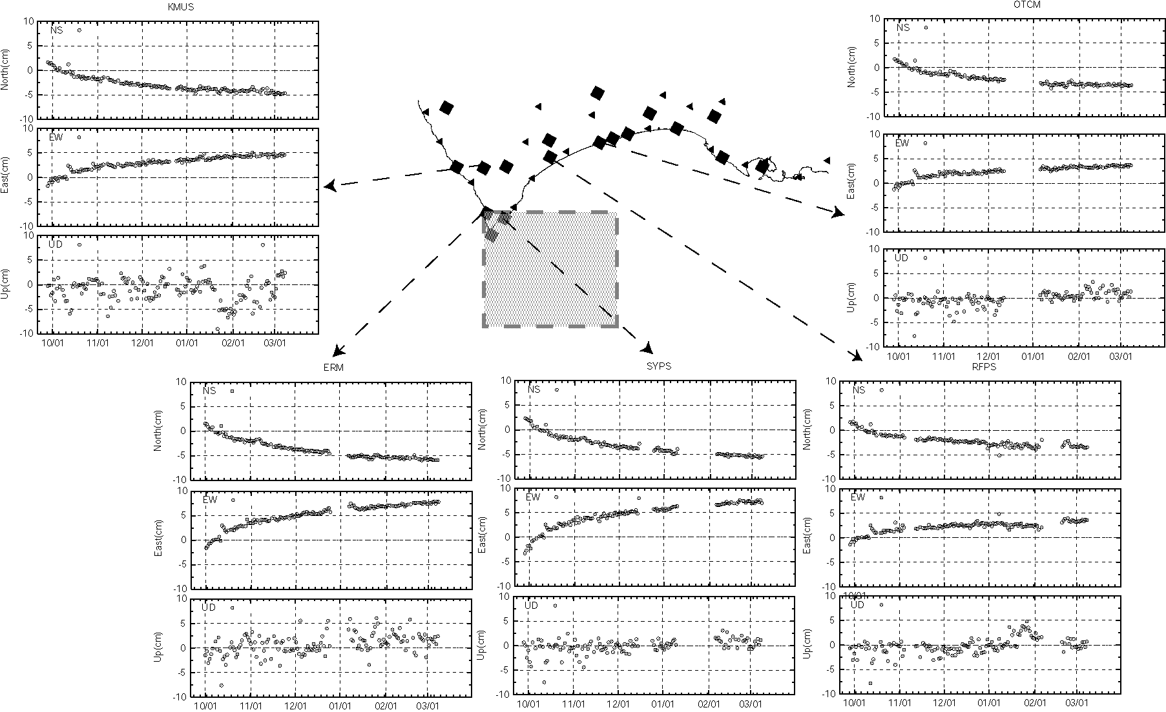

Figure. Time series of coordinates from the 28 September 2003 to the end of April of 2004.

The postseismic deformation rates were well characterized by logarithmic decay functions with around 10 days relaxation times. This suggests that postseismic deformation was due to afterslip on the fault following the large earthquake.

