TESTING PREDICTIONS OF THE DEGREE OF PLATE COUPLING IN THE KURIL SUBDUCTION ZONE

Mark Simons¹, Jeff Freymueller² and Mikhail G. Kogan³
¹California Institute of Technology, Pasadena CA 91125, USA.
E-mail: simons@caltech.edu
²University of Alaska, Fairbanks AK 99775, USA. E-mail: jeff@giseis.alaska.edu
³Colombia University, Palisades NY 10964, USA. E-mail: kogan@ldeo.columbia.edu

Subduction zones are typically classified as falling between two end-member groups, Chileanand Mariana-type (Uyeda and Kanamori, 1979), with large scale inter-arc differences in seismogenic behavior usually attributed to variations in age and convergence rate of the subducting plate (Kanamori, 1986), and normal tractions on the plate interface (Scholz and Campos, 1995). In contrast to this focus on differences between subduction zones, two recent studies have found a strong global correlation between along-strike variations of gravity and topography within a given subduction zone and the principal locations of seismic moment release in large plate interface earthquakes (Song and Simons, 2003; Wells et al., 2003). In particular, these studies (henceforth referred to as SS03 and W03) found that most large earthquakes occurring on the shallow subduction interface occur in regions where trench-parallel gravity and topography anomalies (TPGA and TPTA) are negative, and regions of positive TPGA and TPTA appear to not experience significant seismic moment release. In addition, geodetic studies have identified areas of both high and low strain within a single subduction zone, inferred to represent along-strike variations in the strength of plate coupling. In Alaska, Zweck et al. (2002) showed that the along-strike variations in present-day strain along ~1000 km of the eastern Alaska-Aleutian subduction zone correlate with along-strike variations in moment release during the last earthquake cycle. All of these observations suggest a picture of subduction zones in which along-strike variations in seismic behavior within a given subduction zone are as great as differences between subduction zones. This picture implies that frictional properties of the plate interface can vary over short distances and may control long-term seismic moment release. The conclusions reached by SS03 and W03 suggest that asperities of great earthquakes are persistent and not ephemeral, that there is a close relationship between seismogenic behavior and geologic evolution of the forearc, and that we may be able to predict where areas of high moment release will be in future earthquakes (although not, of course, the timing or exact moment).

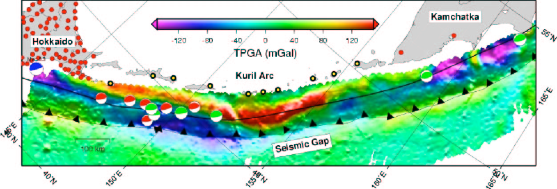

Figure 1. TPGA (color) for the Kuril-Kamchatka subduction zone draped over bathymetry (intensity). Moment tensors from the Harvard CMT from 1976 to 2002. The black barbed line indicates the approximate location of the trench and the solid black line indicates the approximate location of the 50-km-isodepth on the Benioff zone. Yellow and red dots indicate proposed and existing GPS sites, respectively. Note the large positive TPGA that approaches the trench. Also note the large seismic gap corresponding to the region of positive TPGA.

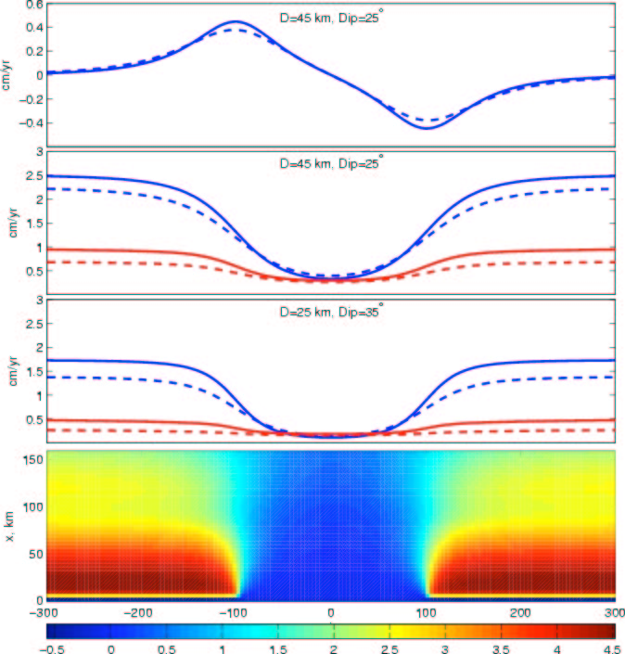

Figure 2. Displacement field as predicted from a backslip model for interseismic deformation in a subduction zone. (Bottom) Trench perpendicular horizontal velocities for an 8 cm/yr convergence velocity, a locking depth, D, of 45 km, a thrust interface dipping at 25 , and an imbedded 200-km-long uncoupled zone. (Top) Trench-parallel profiles of trench parallel velocities evaluated at 130 km (solid) and 150 km (dashed) from the trench. (2nd from top) Trench perpendicular velocities (blue) and vertical velocities (red). (3rd from top) Same as above, but for D = 25 km and a thrust interface dipping at 35 .

The Kuril Arc offers an ideal location to install a linear array of continuous GPS instruments to perform a blind test of a SS03 prediction (figures 1 and 2). The central Kurils have no record of large earthquakes along the thrust interface (e.g., Kuzin et al., 2000). There are two obvious possibilities: either the large earthquakes in this region have yet to occur, or they will never occur. SS03 finds a large region of positive TPGA over the plate interface in the central Kuril, and thus predicts this region to be relatively uncoupled relative to the regions north and south of it (Figure 1). A continuous Kuril-wide GPS network could also detect the presence of any aseismic transients, such as those found at all other continuously monitored coupled subduction zones. Any continuous GPS network that is installed in the Kuril Arc should be accompanied by a complementary yearly campaign survey of each instrumented island to detect local volcanic transients. Such a study could be augmented with regular InSAR measurements to detect and isolate local (as opposed to regional) deformation.

