RAPID NEURONET INVERSION OF 2D MAGNETOTELLURIC DATA FOR MONITORING OF COMPLEX GEOELECTRICAL SECTIONS

M.I. Shimelevich, E.A. Obornev, S. Gavryushov
Moscow State Geological Prospecting University, 117997, Miklukho-Maklaya str., 23, Moscow, Russia

For the last years, examples of the artificial neural network (ANN) technique applications have been presented for solution of the inverse problems of the electromagnetic soundings [Spichak and Popova 1998, Shimelevich and Obornev 1999], where it was shown that this method was effective at 2D and 3D magnetotelluric (MT) imaging when the number of the geolectric model parameters is about 10 [Spichak and Popova 2000, Shimelevich et al. 2001], i.e., the solution is sought within a narrow class of models. An important peculiarity of almost instant inversion by the learned ANN makes this approach to be attractive for real-time monitoring of electromagnetic characteristics of the medium. It should be added that the ANN could be efficiently applied to the monitoring of a few parameters of the section using a rarified set of measurements [Shimelevich et al. 2003]. An application of the ANN technique to the inverse problems of MT soundings requires solving many forward problems at different values of geoelectric parameters and «training» the ANN with this database when both input and output data are known for this set of samples. The first step towards ANN interpretation of geolectric media described by tens of parameters and establishing a connection between sensitivity of inversion to the noise in the field data and errors of ANN training was done in works [Shimelevich et al. 2001, 2002]. It was shown that relative ANN errors in seeking parameters of the medium reflected sensitivity of fields to those parameters and when the learned ANN inverses noised data, the field misfit norms do not exceed a sum of the non-noised inversion misfit norm and norm of the added noise.
In the present work the method is extended to 2D systems comprising of hundreds of parameters, which allows us to study a relatively wide class of geolectric media. In this case the sample database has to involve solutions of tens of thousands forward problems and its computation can be possible only due to the progress in parallel computing. We present results of ANN inversion of synthetic MT data for several such classes of geoelectric models. In Fig. 1 an example of inversion of a 2D geoelectric section is shown. In this model conductivity is sought at nodes of a fixed regular grid. Between the nodes the conductivity is interpolated by a two-dimensional spline. At learning the database of forward modeling samples, each node resistivity independently varies from 2 to 10,000 ·m. The upper layer is described explicitly. Its thickness varies from 0 to 4 km. The conductivity of the upper layer is constant in the vertical direction, but linearly varies between centers of the blocks in horizontal direction. The resistivity model is described by 233 parameters in total. The learning data are apparent resistivities and phases measured along the 100 km survey at 13 periods from 0.01 to 25 seconds. The database comprises 22,400 forward modeling samples. Testing the learned net on 5,600 independent forward modeling samples shows relative parameter errors of a few per cent for the upper layer and less that 15 per cent for nodes situated not deeper than 10 km. Relative field misfits obtained at this testing are less that 4 per cent. One can see an impressive agreement between the true model and a result of interpretation shown in Fig. 1, especially taking into account that the process of the inversion with a learned ANN takes a few seconds on a PC. The conductivity and thickness of the upper layer are found with accuracy within a few per cent.

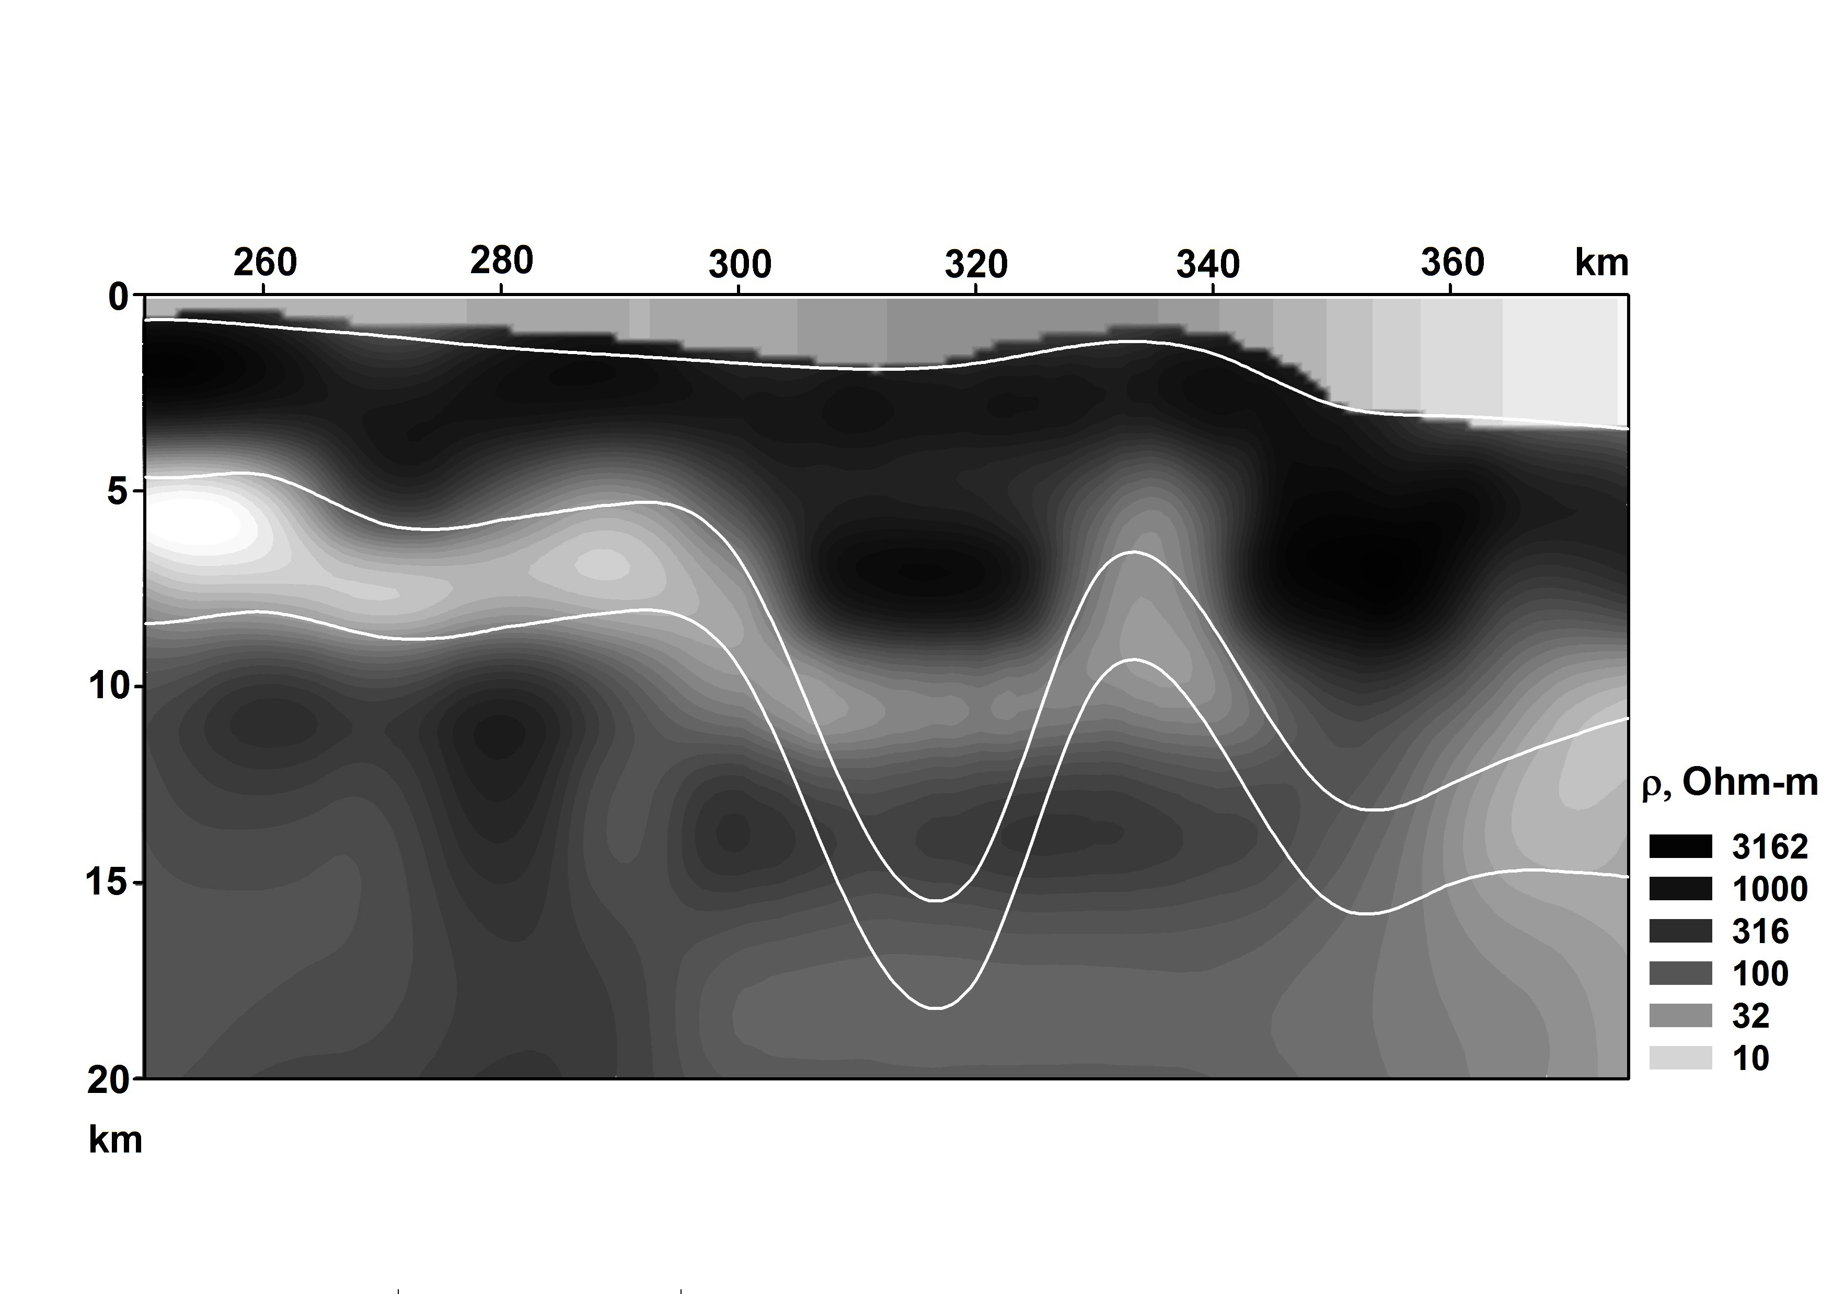

Fig.1. Comparison of an ANN inversion and the true model of the section. White lines are true interfaces between the layers of different conductivity. The second layer resistivity is 2500 ·m, the third layer resistivity is 5 ·m and the bottom resistivity is 5000 ·m.

The rapidness of the inversion makes the method to be attractive for problems of geoelectrical monitoring. Instead of expensive solving the inverse problem every time, one has to perform massive parallel calculations in advance to obtain a satisfactory parametrization of the geoelectric medium in the region studied. After that 2D and even 3D MT data can be interpreted almost instantly to monitor the conductivity changes. It is important that after detailed establishing the model in the region, the method produces inversions stable to noise and unknown details of the upper part of the section. To illustrate the sensitivity of the method, the test model from Fig. 1 was changed. The shape of the second conductive layer was slightly affected at one place. As follows from results of inversion, the changes were reflected in the interpretation of the data by means of the same learned ANN.

References

- Spichak, V.V. and Popova, I.V. (1998) Application of the neural network approach to the reconstruction of a three-dimensional geoelectrical structure. Izvestiya, Physics of the solid earth, 34, 33-39.
- Spichak, V.V. and Popova, I.V. (2000) Artificial neural network inversion of magnetotelluric data in terms of three-dimensional earth macroparameters. Geoph. J. Int., 142, 15-26.
- Shimelevich, M.I. and Obornev, Ye.A. (1999) The method of neural neworks applied to the approximation of inverse operators in electromagnetic sounding problems Izvestiya Vuzov,Geology and prospecting, 2, 102-116.
- Shimelevich, M.I., Obornev, Ye.A., Gavryushov, S.A. (2001) A method of designing neural networks for solving multiparametric inverse problems of magnetotelluric sounding. ibid, 6, 129-137.
- Shimelevich, M.I., Obornev, E.A., Gavryushov, S.A. (2002) Neuronet approximation of the inverse MT operators for geoelectrical monitoring. Proceedings of III International Workshop on Magnetic, Electric and Electromagnetic Methods in Seismology and Volcanlogy (MEEMSV-2002), September 3-6, Moscow, pp. 59-62.
- Shimelevich, M.I., Obornev, E.A., Gavryushov, S.A. (2003) Application of neuronet approximation to the solution of geo-electromonitoring problems. Izvestiya Vuzov,Geology and prospecting,4, 70-71.

