INITIAL RESULTS OF GPS MEASUREMENT IN PRIMORSKI KRAI
N.V. Shestakov¹, M.D. Gerasimenko¹, A.G. Kolomiets¹, G.N. Gerasimov¹,
A.A. Gavrilov², M. Kasahara³ and T. Kato⁴

¹Institute of Applied Mathematics FEBRAS, Radio st., 7, Vladivostok 690041, Russia
²Pacific-Ocean Institute of Oceanology FEBRAS, Baltiyskaya st., 43, Vladivostok 690041, Russia
³Institute Seismology and Volcanology, Hokkaido University, Kita 10, Nishi 8, Kita-ku, Sapporo 060-0810, Japan
⁴Earthquake Research Institute, University of Tokyo, Bunkyo-ku, Tokyo, 113-0032, Japan

Numerous geological and geophysical investigations suggested that geological history of Primorye was characterized by a high tectonic activity. Such activity was accompanied by significant horizontal and vertical Earth crust movements and deformations [1, 4]. More than ten large faults and a lot of smaller faults were discovered in Primorye [2]. The most important tectonic unit in Primorye is the Central Sikhote-Alinsky Fault (CSAF). It propagates through Primorsky and Khabarovsky regions almost along a straight line, and controls their tectonic and geologic settings. The CSAF extends to the north-east along the 20-25° azimuth. It is clearly marked in the landscape and easily recognized in satellite images of this territory for more than 1000 km (figure 1). According to geological and geophysical investigations the main crustal displacements (left-lateral) along the fault occurred in Late Cretaceous. According to geologic estimates the total amplitude of displacements comprised 200 km [1]. Significant horizontal and vertical slips are also identified for other faults in Primorye [2, 4 and others]. However, the information about present geodynamic activity in Primorye is very scarce and often inaccurate. Only in a few cases it is supported by instrumental measurements (repeated leveling and sea level observations) [3].
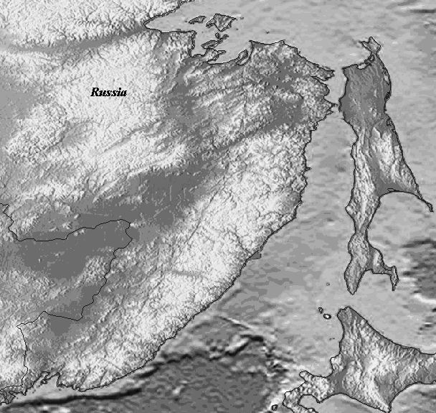
In order to fill the gap in instrumental measurements, the first two GPS stations of the Primorsky Geodynamic GPS Network (PGGN) - KAVL and NKHD were installed in November 2001 as a part of the joint Russian-Japanese project. The station KAVL was destroyed in the middle of 2003. During the next three years GPS observations at the stations ROSH, GRNT, SMHK and TERN have been carrying out. In addition to them, the GPS station VLAD of the Western Pacific Integrated GPS Network (WING) has been continuously operating since 1995 in Vladivostok. PGGN station's locations are shown in figure 1. Location of the IGS station KHAJ is also shown on the same picture.
CSAF
TERN
SMHK
KHAJ
ROSH
NKHD
GRNT
VL
KAVL
China
Hokkaido
Sakhalin
Fig.1. Scheme of the PGGN station's locations.
- periodically observed GPS station;
- continuous GPS station;
VL – VLAD station (WING network, Vladivostok);
KHAJ – IGS station (Khabarovsk).
Campaign GPS observations are performed using all stations of our GPS network, excluding the VLAD. Dual frequency GPS receivers Ashtech Z-12 with 30-sec sampling interval of data recording are used. Each campaign covers a time span from a few weeks to several months. Exactly the same set of GPS equipment is used for performing observations at every station. The VLAD station is equipped by the dual frequency GPS receiver Trimble 4000SSE.

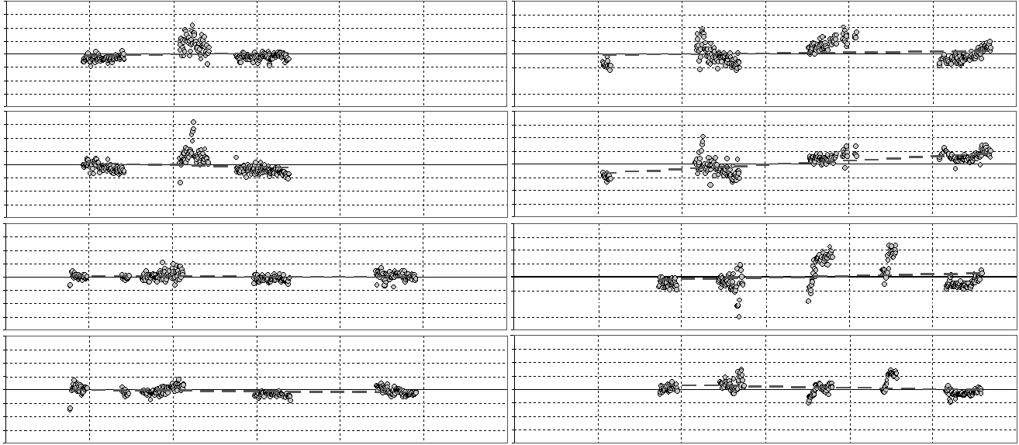
N-S, mm
20
-20
0
10
-10
E-W, mm
20
-20
0
10
-10
N-S, mm
20
-20
0
10
-10
E-W, mm
20
-20
0
10
-10
N-S, mm
20
-20
0
10
-10
E-W, mm
20
-20
0
10
-10
NKHD (0.0±0.1 mm/yr )
RMS=1.3 mm
KAVL (0.7±0.4 mm/yr )
RMS=2.7 mm
KAVL (-1.4±0.4 mm/yr )
RMS=3.1 mm
ROSH (0.6±0.3 mm/yr )
RMS=3.5 mm
NKHD (-0.4±0.1 mm/yr )
RMS=1.6 mm
ROSH (3.1±0.2 mm/yr )
RMS=3.9 mm
GRNT (1.0±0.5 mm/yr )
RMS=4.8 mm
GRNT (-0.9±0.3 mm/yr )
RMS=2.5 mm
2002.0 2003.0 2004.0 2002.0 2003.0 2004.0 yr

Fig.2. Raw time series of horizontal positions of the PGGN stations. The estimated velocities with standard errors by ordinary linear regression are shown in parentheses. Root-mean-square (RMS) values for each component also are shown.
All GPS data for a period of 2001-2004 were processed using Bernese Ver. 4.2. software for estimating of horizontal velocities of the network stations with respect to the VLAD station.
Stations SMHK and TERN were excluded from the processing, because the total amount of GPS data acquired so far is less than required for analysis at these points. Processing results are shown in figure 2. Based on these results it is possible to make following conclusions:
1. The estimated velocities for all stations relative to the VLAD station are not higher than the level of accuracy, because their formal errors are underestimated by factor of 3 to 5. The station ROSH is an exception. Its eastern velocity component is equal to 3 mm/yr. It is not small and could be related to a slip along the fault located near the station.
2. Crustal movements along the largest faults located to the East from the VLAD are not higher than a few millimeters. This indicates a low level of present tectonic activity in Primorsky region. At the same time we can not completely exclude the existence of more significant movements (including those along the CSAF), because the available data may not be enough for making reliable conclusions.
3. Processing results are significantly affected by seasonal variations. Such variations may be caused by changing atmospheric conditions at the GPS sites (troposphere), geodetic monuments instability, and some other reasons.
4. Campaign GPS measurements are useful for determining the velocity variations at each station. However, for precise velocity estimates and for their reliable interpretation at least two or three years of continuous GPS measurements are required.
This work was supported by Russian foundation for basic research (grant number 03-05-64275-a).

References

- Ivanov B. A. The Central Sikhote-Alinsky Fault. Vladivostok, 1972, 114 pp.
- Nazarenko L.F., Bazhanov V. A. Geology of Primorsky Krai. Part III. Main tectonic settings and evolution history. Preprint. Vladivostok, 1987, 59 pp.
- Oleinikov A.V., Oleinikov N. A. Geologic indicators of seismicity and paleoseismicity of southern Primorye. Vladivostok, 2001, 183 pp.
- Utkin V.P. Strike-slip faulting, magmatism and ore-formation. Moskow, Nauka, 1989, 163 pp.

