AFTERSHOCKS OF DEEP EARTHQUAKES IN THE KAMCHATKA-ALEUTIAN JUNCTION ZONE

Vadim Saltykov
Kamchatkan Seismological Department, Geophysical Service, RAS
9, Piip Blvd., Petropavlovsk-Kamchatsky, 683006, Russia. E-mail: salt@emsd.iks.ru

Absence of aftershocks after deep earthquakes is usual phenomena. However, during detail seismological observation in Kamchatka there are four large (M > 6.0) earthquakes on the depth from 75 to 250 km, which were accompanied aftershock sequence. The next features are noted:
- epicenters of these earthquakes are located by compact group in the north of Kronotsky Peninsula;
- in this place there are no deep earthquakes without aftershocks.
A presence of aftershock process points to significant elasticity of medium on this depth interval. May be this effect can be explained by regional features. This area is Kamchatka-Aleutian junction zone. Just here the west bend of Kurile-Kamchatkan trench, seismofocal stratum and volcano chain are observed.

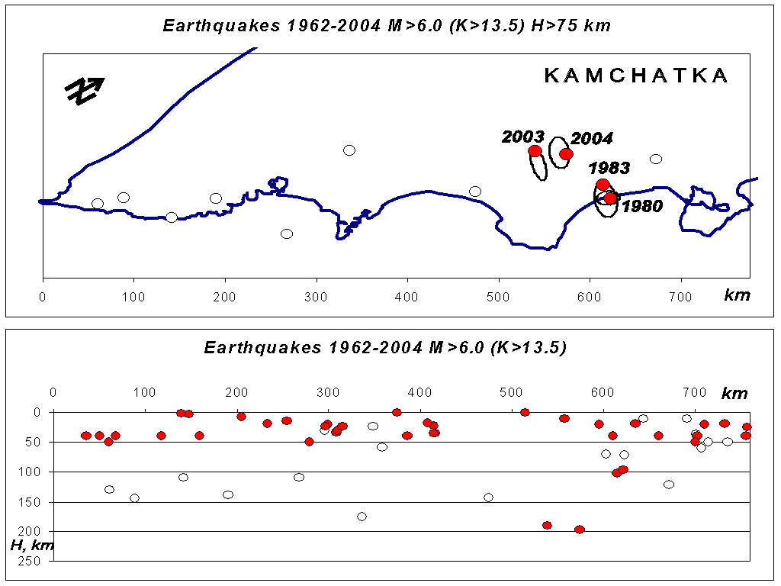

Fig. Above: Map of Pacific cost of Kamchatka with marked epicenters of deep (depth > 75 km) earthquakes with magnitude M>6.0. Black circles corresponds to the earthquakes, which have aftershocks. White circles corresponds to single earthquakes. Ellipses locate sources of earthquakes. Below: Projection of Kamchatkan earthquake (M>6.0) hypocenters onto vertical plane. Legend is the same.

