КАЛЬДЕРНЫЙ КОМПЛЕКС ПОЛОВИНКА-ОДНОБОКАЯ-АКАДЕМИИ НАУК,

POLOVINKA-ODNOBOKAYA-ACADEMII NAUK CALDERA COMPLEX, KAMCHATKA: STRUCTURAL POSITION AND MAGMATIC EVOLUTION

Vladimir L. Leonov and Yelena N. Grib

Piip Blvd.9, Petropavlovsk-Kamchatsky, 683006, Russia. E-mail: lvl@kcs.iks.ru

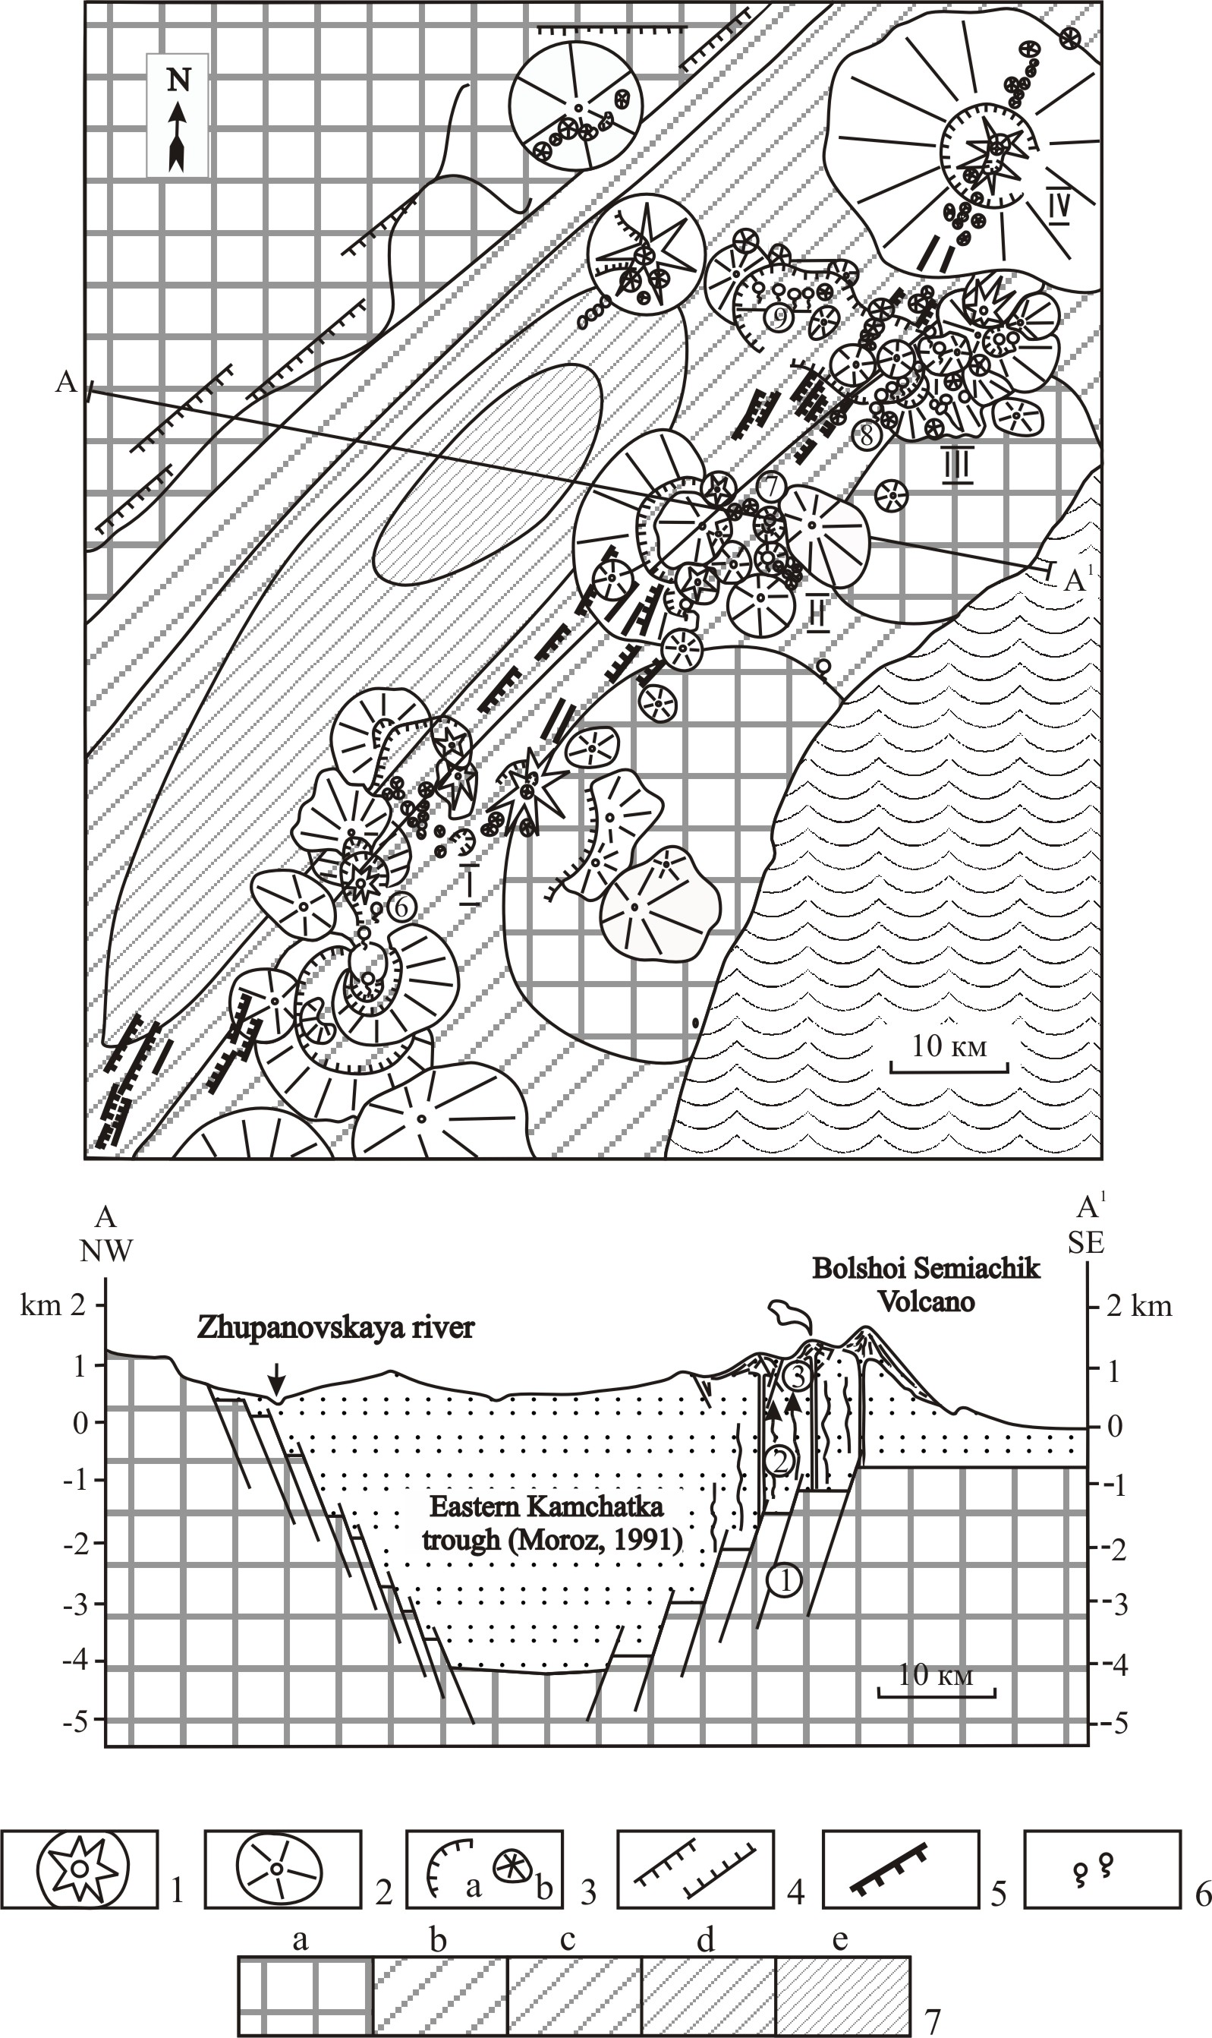
Detailed geologic, petrologic and geochemical studies of the Polovinka-Odnobokaya-Academii Nauk caldera complex have been completed recently. The caldera complex is located in the central part of the Eastern Kamchatka, in the southern part of the Karymsky volcanic center (fig. 1). There are seven calderas formed during the last 0.18-0.15 Ma. The structural position of the Polovinka-Odnobokaya-Academii Nauk caldera complex has been analyzed and compared to that of other Eastern Kamchatkan caldera complexes. It appears that the later are located within the boundaries of the Pliocene-Quaternary volcanic belt and confined to the areas,

Fig.1. Map and cross-section of volcanoes, high-temperature hydrothermal systems and basement troughs in the central part of Eastern Kamchatka. 1 - Late-Pleistocene volcanoes; 2 – Middle-Upper-Pleistocene volcanoes; 3 - calderas (a), small monogenetic volcanoes and scoria cones (b); 4 - main north-east faults; 5 – Late-Pleistocene – Holocene fissures and normal faults; 6 - thermal springs; 7 – depth of the basement, km (after Moroz, 1991): a - <1; b – 1-2; c – 2-3; d – 3-4; e - >4. Numbered volcanic centers: I – Karymsky, II – Bolshoi-Semiachik, III – Uzon-Geyzerny, IV – Krasheninnikov. Numbers in circles indicate the high-temperature hydrothermal systems (Leonov, 2000). A-A′ - line of the cross-section. The lower portion of the figure shows the schematic cross-section along the line A-A′. Hatched area is the basement. Numbers in the circles indicate the following zones: 1 - boundary faults of troughs, which serve as deep structural traps for the magma and hydrothermal fluids, 2 – ascent of magmas and hydrothermal fluids, 3 - Late-Pleistocene - Holocene fissures and normal faults near the surface.

where this belt is superimposed on deep troughs of the basement. The main structural elements controlling the positions of the caldera complexes are the faults, which bound such troughs. Similarly, the Polovinka-Odnobokaya-Academii Nauk caldera complex is located where the faults bounding the basement troughs intersect with the complicating faults. Perhaps the intersecting faults formed stable and long-lived permeable zones within the earth crust, along which magmas and hydrothermal fluids were able to ascend to the surface and to form complex volcanic structures.
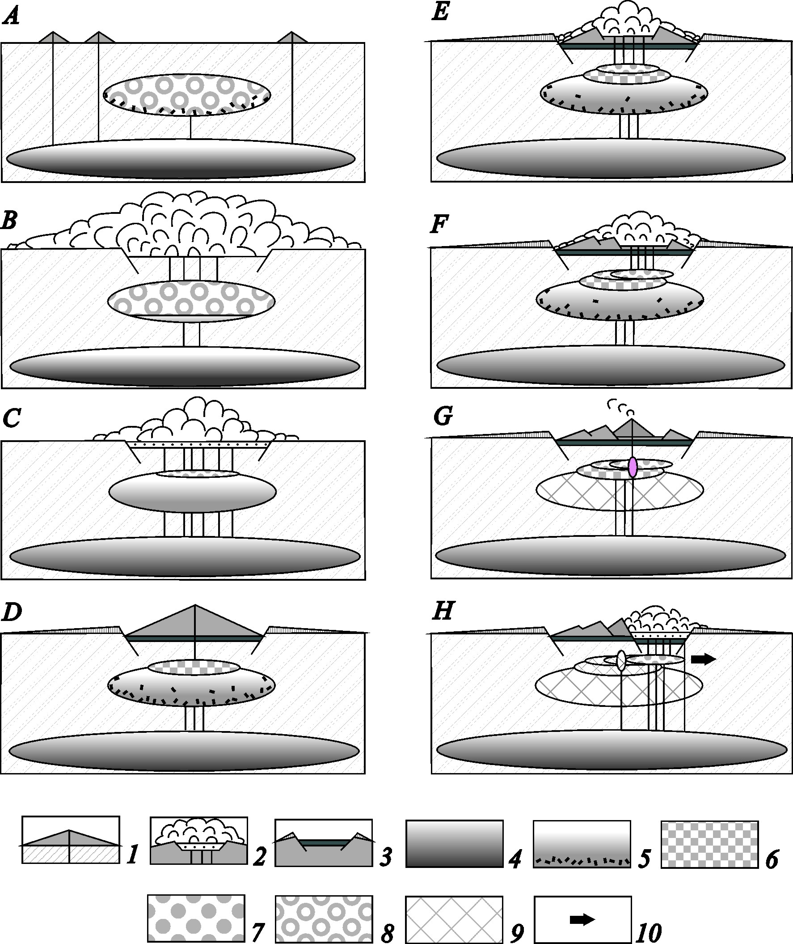
Fig.2. Schematic diagram showing a sequence of magma withdrawals from the magma chambers of the Polovinka-Odnobokaya-Academii Nauk caldera complex as the eruption progressed. The periods: A – pre-caldera (~0.2 Ma), B - formation of Polovinka caldera (~0.18-0.15 Ma), C – formation of the upper part of cinder agglomerates, connected with Polovinka caldera, D - formation of Odnoboky volcano (~0.11 Ma), E - formation of the first Odnoboky caldera (~0.08 Ma), F – formation of the second Odnoboky caldera (~0.06 Ma), G - formation of Academii Nauk volcano (~0.04 Ma), H - formation of Academii Nauk caldera (~0.03 Ma). 1 - volcano and its conduit; 2 - caldera during its formation, caldera lake and eruptions occurring from the lake; 3 - caldera after its formation filled with lacustrine deposits, and tuffs and ignimbrites deposited on the flanks; 4-8 – magma chambers with different compositions of magma: 4 - basaltic (chambers in the lower crust), 5 - basaltic with fractionation of the crystals (chambers in the upper crust), 6 - andesitic, 7 - dacitic, 8 - rhyolitic; 9 – crystallized magma chambers; 10 - direction of a probable lateral displacement of chambers.

The melt in the upper crust chambers was compositionally evolved prior to eruption, which is suggested by the gradients in composition, temperature and volatile contents for each caldera-forming eruption. The disequilibrium mineral assemblage of the products of climactic eruptions, as well as the occurrence of the basaltic scoria layers in the pumice tuff sections and the peculiarities of the 1996 eruption in Karymsky Lake, provide an evidence for the system of connected magma chambers, which situated at different depths (fig.2). We estimated the minimum depth for the roof of the upper crust chamber as 5-7 km (1.2-2.2 kbar). The presence of the high-aluminum hornblende (pargasite) in the silicic pyroclastic rocks is the evidence for the upper crust magma system with the gabbro-diorite layer or sill at depth of 11-12 km (3.6 kbar). The similarity of the isotope compositions (Sr and Nd) of volcanic rocks ranging from basalts to rhyodacite and the linear trends in compositions of mineral phases suggest a comagmatic origin of these magmas. The presence of the holocrystalline enclaves (cumulates) in pyroclastic rocks implies an important role of the crystal fractionation in the origin of compositional diversity of igneous rocks of the study area. Perhaps, the nested structure of the Polovinka-Odnobokaya-Academii Nauk caldera complex and the repeating pattern in its eruptive activity are due to the inherited, long-lived magma-feeding system and cyclic tectonic activations in a latitudinal fault zone. The sites of intersection of this fault zone with the abyssal permeable zone of the northeastern strike are the places where the most intensive volcanic and hydrothermal activity is concentrated.

