GEOLOGICAL STRUCTURE AND PETROCHEMICAL FEATURES OF MAGNESIAL BASALTS OF KHARCHINSKY VOLCANO, (KAMCHATKA)

N.V.Gorbach, S. A. Khubunaja
Institute of volcanology and seismology the Russian Academy of Science, Petropavlovsk-Kamchatsky, Russia. E-mail: n_gorbach@mail.ru

High-magnesian basalts of island arcs are considered to be derivatives from parent melts that were in equilibrium with upper mantle [1, 2, 6]. The post-Pleistocene Kharchinsky volcano is the only stratovolcano in Kamchatka, which is composed mainly of magnesial volcanic rocks [1].
The central part of the volcano is exposed by erosion. This provides a unique opportunity to investigate high-маgnesian magmas of different degrees of differentiation, which sequence has erupted throughout the life of the volcano. The effusive section of the volcano consists of small lava flows of magnesian basalts with layers of coarse pyroclastic rocks of the same composition (fig. 1). Sub-parallel dykes of sub-alkaline dolerite-basalts, doletrites, gabbro-dolerites, basaltic andesites, and spessartites are exposed inside the caldera of the volcano.
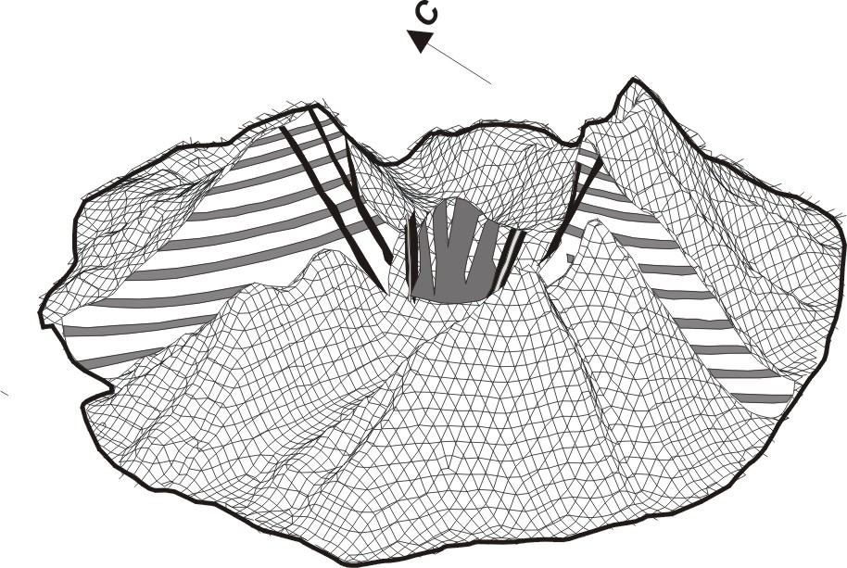
Based on petrographic examinations and microprobe analyses we identified three types of basalts: (1) magnesian olivine-clinopyroxene, (2) plagioclase-olivine, and (3) high-magnesian. The youngest basalts are characterized by elevated concentrations of alkalis and contain potassium feldspars. The concentrations of alkalis in the groundmass glass are the same as that of whole rocks. Olivines in basalts and olivines in ultramafic xenoliths from dikes show significant compositional differences, i.e. the olivines from xenoliths are characterized by higher Mg0 and lower CaO (0.01-0.03 wt %) concentrations, which suggests the mantle origin of the later.
Magnesian basalts belong to moderately-potassic and high-potassic calc-alkaline rock series (fig. 2). An insignificant upward increase of concentrations of alkalis is observed across the lava cross-section. The latest and most differentiated portions of melts, which occur in dikes of the central part of the volcano, are characterized by high concentrations of alkalis.
All eruptive products of Kharchinsky volcano have similar petrochemical and mineralogical characteristics and form uniform series of rocks, which suggests their origin from a single magma source.

References

- Volynets O.N., Melekestsev I.V., Ponomareva V.V., Yagodzinsky G. M.Harchinsky and Zarechny volcanos - the unique centers позднеплейстоценовых магнезиальных basalts on Kamchatka: material structure of volcanic breeds. // Volcanology and seismology. 1999. № 1. With. 31-45.
- Volynets O.N., Ponomareva V.V., Babansky A.D.Magnezial basalts of andesit volcano Shiveluch //Petrology, 1997. Т.5. №2. with 206-221.
- Kutyev F.S., Ehrlich Э.Н. To petrology of basalts of the Kharchinsky group of volcanos. // Бюл.Volcanolog. Stations. 1973. № 49. With. 83-92.
- Menyailov A.A.volcano of mountains Harchinsky // Тр. A lab.volcanology. 1949. issue. 6. with 53-61.
- Hubunaja S.A., Bogojavlenskij S.O., Novgorodtseva T.J., Okrugina A.I. Mineralogical features of magnesial basalts as reflection of fractioning in magmatic chamber of the volcano Kljuchevskoy // Volcanology and seismology. 1993.№3. With. 46-68.

