BEHAVIOR OF STORED MAGMA IN ARC CRUST

John Eichelberger, Pavel Izbekov, and Brandon Browne
Alaska Volcano Observatory - Geophysical Institute, and Department of Geology and Geophysics - College of Science and Mathematics, University of Alaska Fairbanks, Fairbanks, AK 99775 USA

Although the magmatic product of subduction is basalt, truly primitive magma rarely survives transit through arc crust, and even fractionated basalts are often underrepresented. Basalt is generally introduced into the crust as long dikes, as exemplified spectacularly in the 1975 eruption of Tolbachik. Indeed, most arc volcanism is probably dike- rather than pipe-fed, but stalling of wet magmas due to subsurface degassing causes transformation from dike to pipe flow, suppressing surface expression of dike structures. The rise of basalt is further impeded by interaction with stored magmas, yielding a complex output that is a combination of mantle, crustal, and fractionated components.
Repeated episodes of dike intrusion along the same structure- and stress- controlled plane results in development of long-lived and generally crystal-rich magma pods of intermediate bulk composition. These serve to attract subsequent dikes because they perturb the local stress field and because, once breached, they provide an easier path for magma flow than continued dike propagation. It is suggested that large polygenetic cones normally have pods as their immediate sources. If so, such pods can persist for 10⁴ to 10⁶ years. Chemically, they tend to remain in the andesite/dacite bulk composition range because further fractionation is impeded by high melt viscosity and the back-mixing effect of mafic replenishment on the overall pod is limited by prompt, preferential eruption of hybrids.
The state of an andesitic pod is likely related to the size and recurrence interval of replenishment events (Fig.1). Frequently replenished high-temperature pods are normally precipitating plagioclase and pyroxene. Because of their relative fluidity, they erupt uniformly mixed hybrid magmas during replenishment. Karymsky in Kamchatka is an example. Less frequently replenished low temperature pods are normally precipitating plagioclase, hornblende, and beginning to precipitate quartz. A portion of the mafic magma entering these pods «clots» to form enclaves because of the large temperature contrast. Unzen in Japan, Kizimen in Kamchatka, and Dutton in Alaska are examples. Although normal replenishment events erupt only pod magma that has been in direct contact with basalt, large events can expel the dominant unmixed pod volume, as at Pinatubo.
With further cooling, pod crystals form a network and the stored magma as a whole becomes uneruptible. However, we suggest that the network is permeable and can sustain fracturing, so that the interstitial rhyolite or rhyodacite melt can be rapidly extracted by coupled short path-length porous flow and long path-length dike flow. Aplite dikes in arc granodiorite plutons are produced by this phenomenon. This would explain the common crystal-poor but multiply saturated character of silicic caldera-forming magmas. Such extraction may be triggered by externally imposed tectonic or replenishment forces or internal gas pressure. Massive silicic melt expulsion events can carry nearby andesitic pod magma with it, producing the characteristic silicic to intermediate zoning of caldera-forming eruptions.
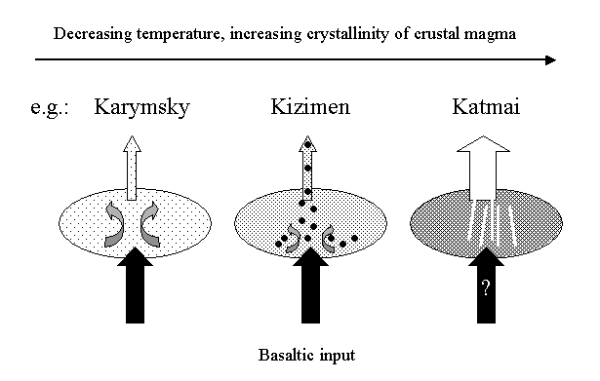

Fig.1. Postulated change of behavior of crustal magma with decreasing temperature and increasing crystallinity. In the Karymsky case, the temperature and viscosity contrast between stored and injected magma are small and thoroughly mixed andesite is promptly erupted after basalt injection. In the Kizimen case, the stored magma has cooled to the point of quartz saturation. Input basaltic magma «clots» and induced convection does not affect the entire magma pod. Stored magma contaminated by mafic enclaves and crystalline debris is preferentially erupted. At Katmai, stored magma has become uneruptible in bulk, but the crystalline network is sufficiently porous to allow rhyolite melt expulsion in response to magmatic or tectonic perturbation.
The above scenario attempts to explain some of the salient features of arc volcanism, including the pervasive evidence of just-before-eruption mixing in intermediate composition lavas and the alternation between long periods of small, similar andesite/dacite eruptions and abrupt silicic paroxysms at arc volcanic centers.

