TIME DEPENDENT MODEL OF HUGE DIKE INTRUSION AT THE 2000 MIYAKE-KOZU VOLCANIC EVENTS, BASED ON GROUND DEFORMATION BY GPS MEASUREMENTS

Masayuki Murase and Fumiaki Kimata
Graduate School of Environmental Studies, Nagoya University, Japan

At the 2000 Miyakejima Volcano eruption, the most disastrous earthquake swarm on record was observed between Miyakejima and Kozujima Islands, which includes five earthquakes of magnitude 6. As the hypocenters of the earthquake swarm distribute linearly to the northwestward from Miyakejima and large ground deformation amounting to 50 cm is observed at Kozujima, some huge magma intrusion models are discussed (Ito and Yoshioka, 2002, Nishimura et al., 2002, Furuya et al., 2003, Ozawa and Miyazaki, 2004). We discuss the time dependent model of the huge dike intrusion associated with the 2000 Miyake-Kozu volcanic event, based on Ground deformation by GPS measurements.
We check the time series of GPS coordinates observed 24 sites at Miyakejima, Kozujima, Shikinejima, Niijima, Toshima and IZ Oshima by GSI, ERI of Tokyo Univ., NIED, HD of JCG, and Nagoya Univ, and remove the co-seismic dislocations by M6 earthquakes from the daily GPS solutions. Precise re-determined hypocenter distributions of the earthquake swarm (Sakai et al., 2003) suggest a multiple magma intrusions of three or four dikes. We assume complex dike intrusion model of three sheets. The locations of complex dike intrusion are estimated from the GPS measurements using Genetic Algorism (GA). After then we divided the period from June 27 to August 27, 2000 to seven stages.
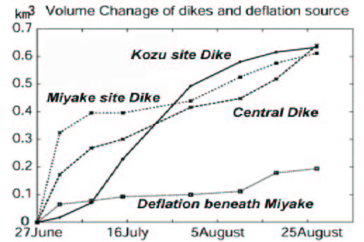
A volume of magma intrusion amounts to 1.5 km3 totally for two months. From the result, it makes clear that a complex magma intrusion is not spatio-temporally. At first stage until July 8, opening is distinguished in the dikes near Miyakejima and center. After July 8, opening is increasing in the dike near Kozujima. The largest opening is recognized the lower part of central dike, which is deeper than 10 km beneath sea level.
We also estimate the deflation sources beneath Miyakejima, and it shows active in two periods, first stage of through July 8 and after August 8, which are correspond the caldera collapse on July 8 and largest eruption amounting to 15 km above on August 18.
We have a speculation that magma supplement of dike in Miyakejima-Kozujima is not only from Miyakejima but also deeper area.

