SILENT EARTHQUAKES AND THE POPOCATEPETL VOLCANO UNREST

Vladimir Kostoglodov¹, М. Carlos¹, Valdés González¹, Luis Quintanar¹,
Kristine M. Larson²
¹ Instituto de Geofísica, Universidad Nacional Autónoma de México, México, D.F., México
²Department of Aerospace Engineering Science, University of Colorado, Boulder, Colorado, USA

Several slow aseismic slip events have been observed in the Mexican subduction zone in Guerrero and Oaxaca states from global positioning system (GPS), precise leveling, and tide gauge records. These events, also called «silent» earthquakes, have equivalent magnitudes M_{w} of >7 and their duration is of 4-6 months.
Two «silent earthquakes» in 1997-1998 [Lowry et al., 2001] and 2001-2002 [Kostoglodov et al., 2002] produced also a noticeable displacement on the Popocatepetl (POPO) volcano (Figure 1), which is located ~400 km from the Middle America trench. Seismic and geodetic monitoring of the volcano was carried out all along its last unrest period since 1994.
Albeit the Popocatepetl activity was relatively lower during the time spans of the slow aseismic events (Figure 2), these observations are very limited for a definite correlation. Slow subduction transients of equivalent magnitude of 6.5-7.5 are about 10 times more frequent than large subduction thrust earthquakes in Mexico. This gives us some chance in revealing a possible interaction between the aseismic slip events and volcanic activity.
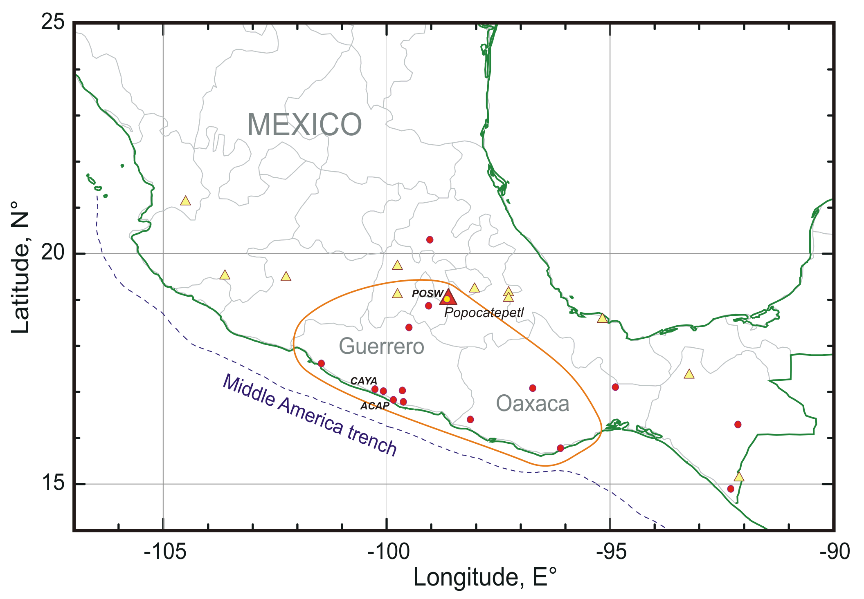
Fig.1. Tectonic setting of the Mexican subduction zone. Triangles show locations of the historic and active volcanoes. A closed curve comprise an area where a notable surface crust displacement have been observed during the slow aseismic slip events in 1998-1999 and 2001-2002. Circles are positions of the GPS permanent stations

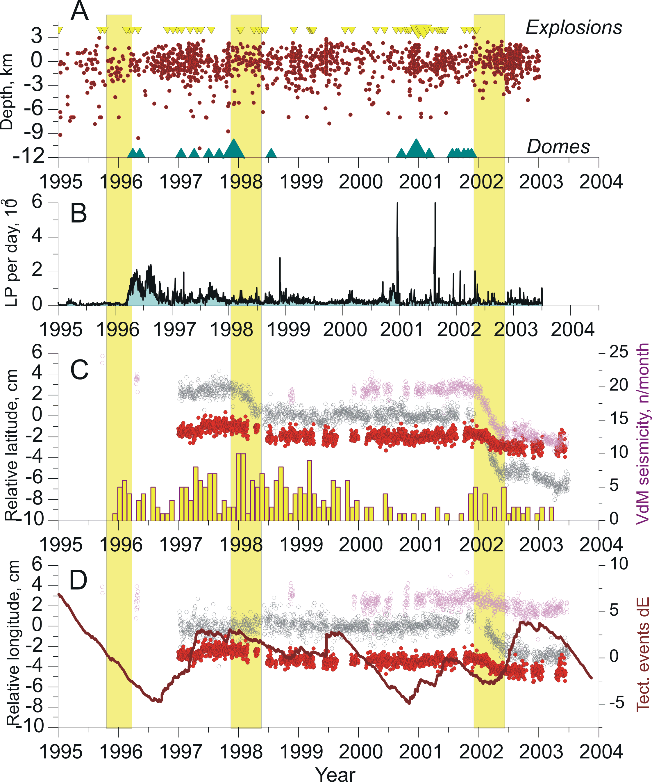

Fig.2. Aseismic slow slip events (vertical yellow bars) and different parameters of the Popocatepetl volcano monitoring. A – Depth-Time plot of the seismicity below the volcano. Inverted triangles on the top indicate the time of the volcanic explosions, and the triangles on the bottom – the crater domes growth. The size of the triangles is proportional to the corresponding effect. B – Number of long-period volcanic tremors per day. C – Relative latitude (NS component) of GPS stations at the POPO (red), CAYA (grey) and ACAP (light magenta) stations. A histogram shows a time distribution of seismicity in the Mexico Valley, which is located to the NE from the POPO. D – Relative longitudes (EW components) of GPS stations (colors association is the same as in C). Continuous dark red line is a variation of the seismic energy released by the tectonic events below the POPO

References

- Kostoglodov, V., K. Larson, S.K. Singh, A. Lowry, J.A. Santiago, S.I. Franco, and R. Bilham, A large silent earthquake in the Guerrero seismic gap, Mexico, Geophys. Res. Lett, 30(15), 1807, doi:10.1029/2003GL017219, 2003.
- Lowry, A.R., K.M. Larson, V. Kostoglodov, R. Bilham, Transient slip on the subduction interface in Guerrero, southern Mexico, Geophys. Res. Lett., 28 , 3753-3756, 2001.

