NON-SUBDUCTION SEISMICITY IN KAMCHATKA: FIRST DATA ON PALEOSEISMOLOGY OF THE EAST KAMCHATKA FAULT ZONE

A. Kozhurin¹, V. Ponomareva², I.V. Melekestsev², V. Acocella³, F.M. Lagmay⁴, D. Rust⁵,
A. Tibaldi⁶, A. Tunesi⁶, C. Corazzato⁶, A. Rovida⁶, A. Tengonciang⁴, and H. Uy⁴
¹ Geological Institute RAS, Moscow, Russia
² Institute of Volcanic Geology and Geochemistry RAS, Petropavlovsk-Kamchatsky, Russia
³ University of Rome III, Rome, Italy
⁴ National Institute of Geological Scienses, University of the Philippines
⁵ Department of Geography and Earth Sciences, Brunel University, United Kingdom
⁶ Department of Geological Sciences and Geotechnologies, University of Milan-Bicocca, Milan, Italy

The overwhelming portion of modern seismic impact on Kamchatka comes from the sources that root within the subduction zone. Shallow seismicity within the peninsula is scarce and does not show any distinct inner pattern that could allow to correlate it with Late Quaternary structures. At the same time, the overriding continental block of Kamchatka hosts a large number of onland faults that cut the land surface and can be therefore classified as active, which means, capable of generating strong seismicity. The major zone of active faults is the East Kamchatka fault zone running between the Central Kamchatka Depression and the Eastern Range (see Figure). The zone is composed of more than a hundred of individual faults performing, as geomorphic evidences suggest, mostly combined normal/right-lateral kinematics, west sides down. The fault lengths fluctuate around 25 to 30 km, the value corresponding to M 6.5-7 seismic events (Wells and Coppersmith, 1994). Yet no modern earthquake surface ruptures have been found within the peninsula so far. First of all, this can be accounted for by likely much longer recurrence intervals than that for subduction-related earthquakes.

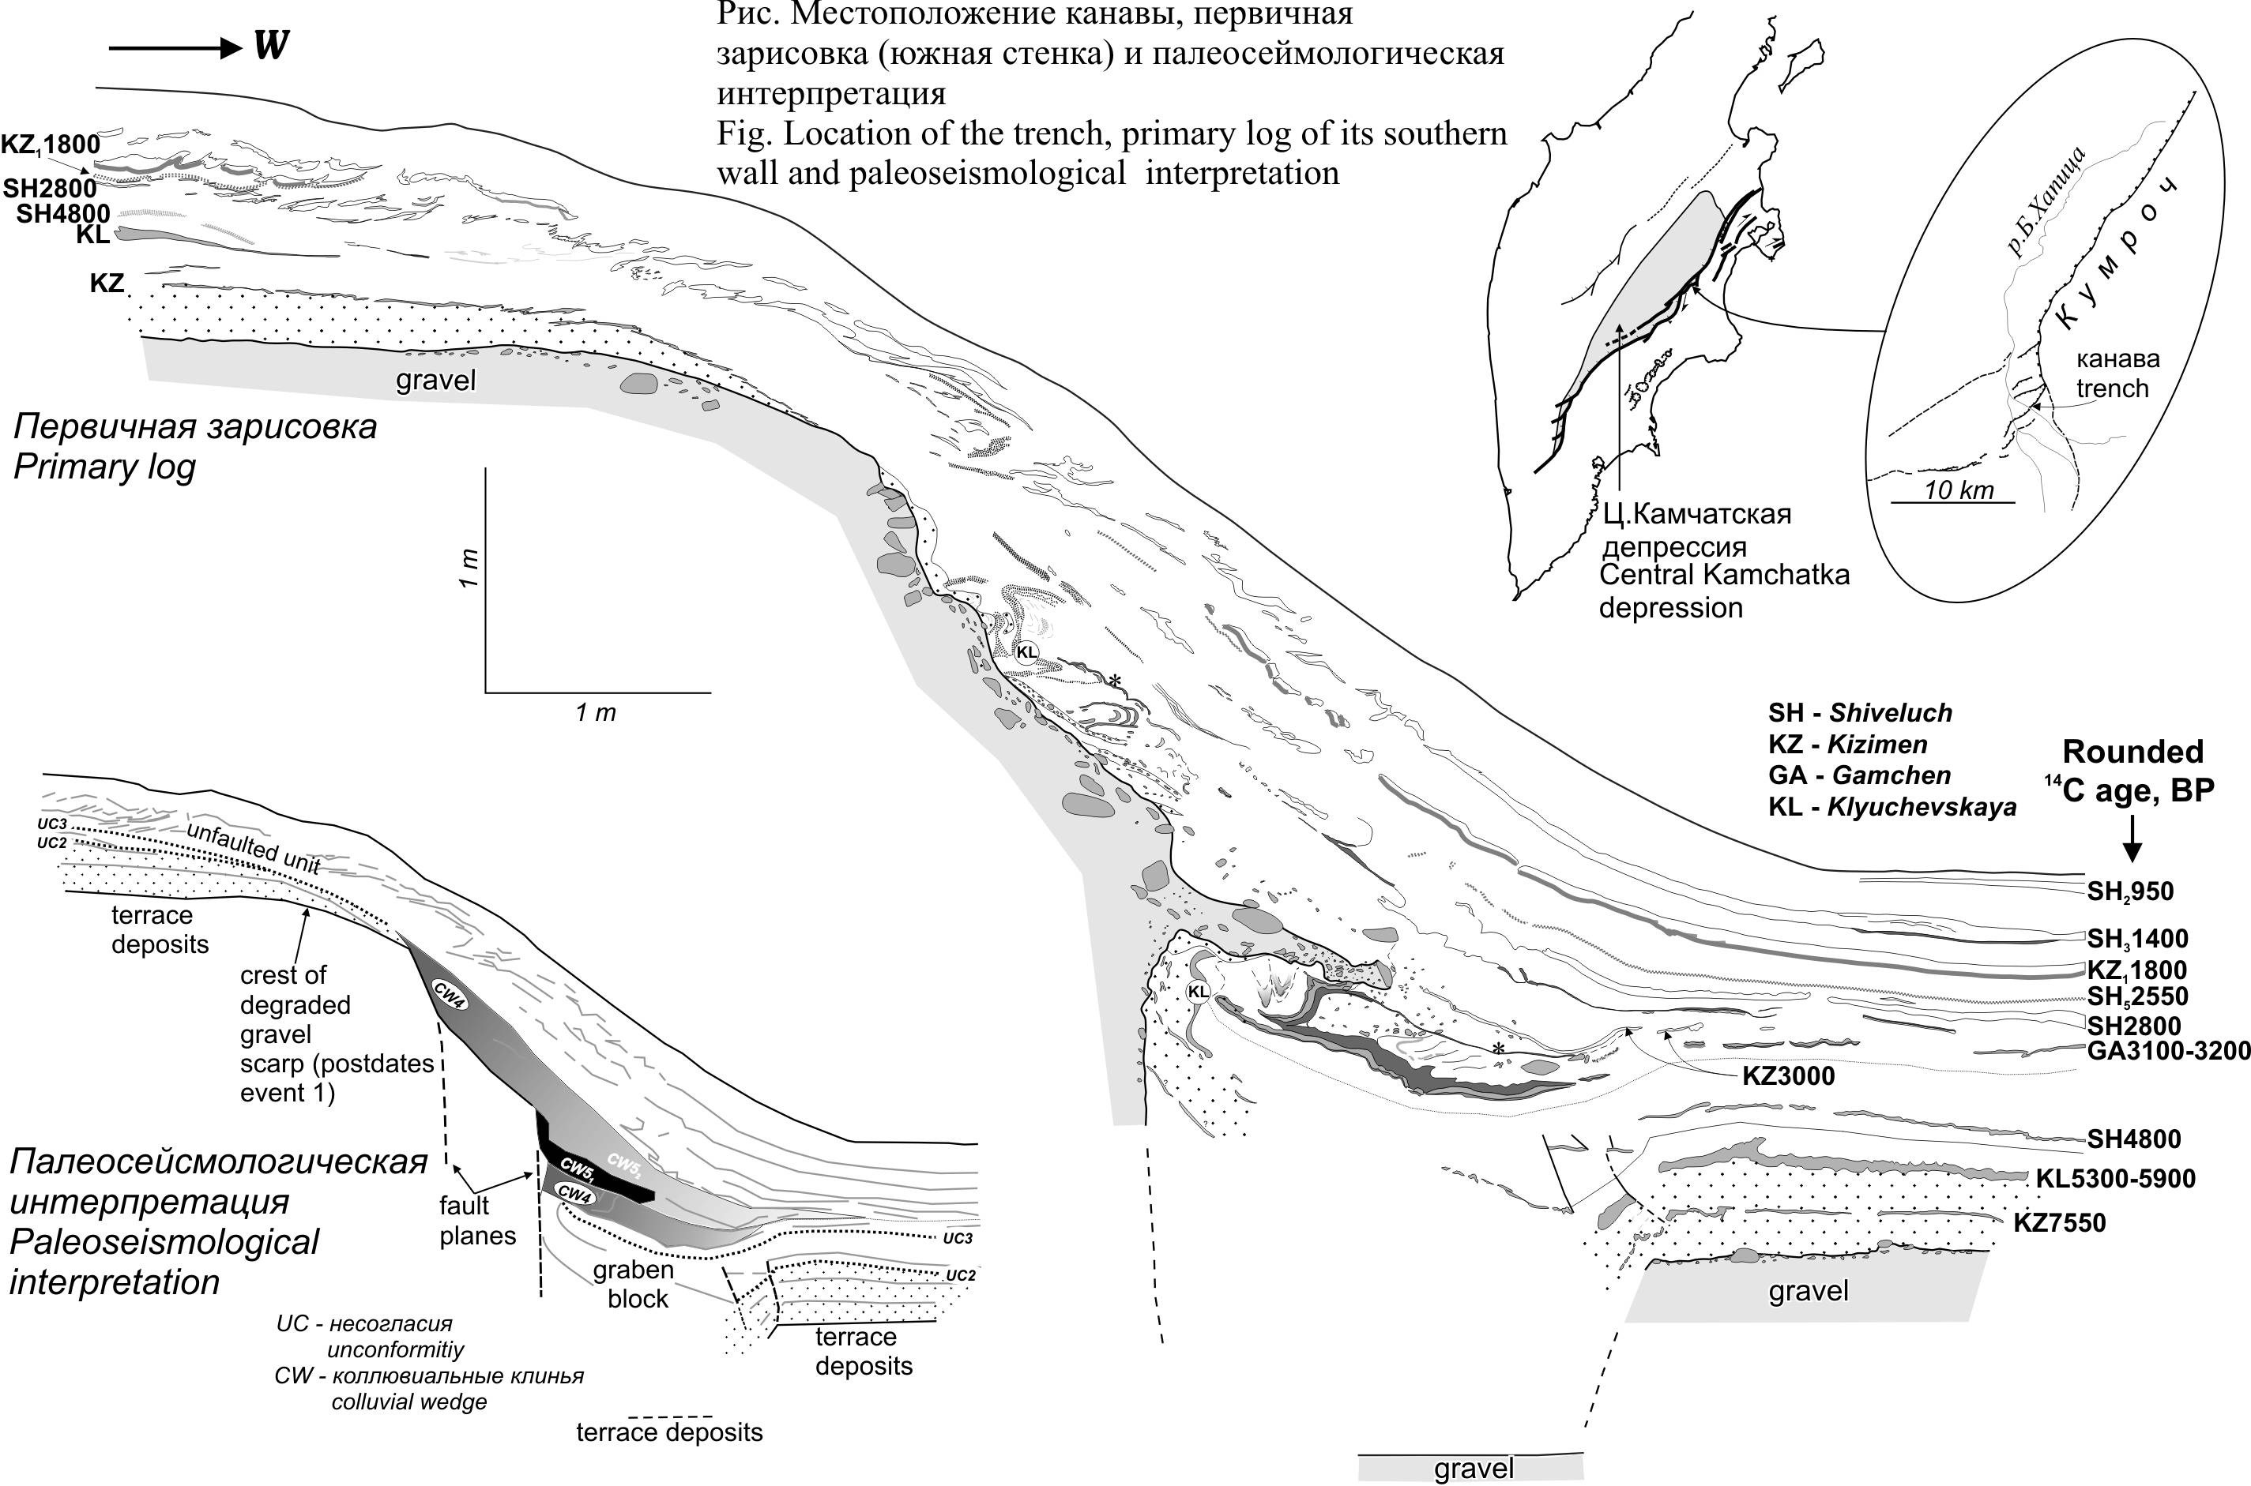

To evaluate paleoseismological parameters of these faults we dug a trench, the first in the Kamchatka Peninsula, across one of subsidiary faults of the major Kumroch fault, which is the northern segment of the East Kamchatka fault zone.
The NE-striking fault we trenched makes a surface northwest-facing scarp up to first meters in the within the Bol’shaya Khapitsa River valley and north of it. On the highest river terrace, this is a single 3.3 m scarp. On the younger terrace, the scarp bifurcates into two lower scarps, their total height remaining roughly the same 3.1-3.2 m. On the youngest of the faulted terraces, the scarp reaches 0.8-0.9 m.
Two main units composing the unvailed section are unevenly sized semi- to well-rounded gravel and soil-and-ash sequence (soil-pyroclastic cover) above. Most distinct evidences of multiple movements on the fault are irregular step-like morphology of the gravel surface and the occurrence of both coarse and finer colluvial material within the soil-pyroclastic cover. Dating the paleoseismic events we relied on the ages of ash layers that provide altogether a perfect system of isochrons. In all, we distinguish five faulting events, which occurred about 10.5 Ka, 6 Ka, 4.5 Ka and 3.2-3.3 Ka years BP. Since the Kizimen ca. 3100 cal. yr BP ashfall the fault has not moved again. The vertical (normal) amplitude of an individual faulting event is about 0.7 to 1 m.
An unusual feature of the fault seismic evolution is a succession of two seismic events, roughly of the same magnitude, that took place one after another within a period of about 200 years about 3.2-3.3 thousand of calibrated years back.
Data we obtained show that assessment of seismic potential of crustal active fault must be a part of long-term evaluation of seismic hazard in Kamchatka.

