SEISMOTECTONIC PATTERN, SOURCE REGION OF VOLCANISM AND ONSET OF A NEW SUBDUCTION CYCLE IN THE KURILE ISLANDS AND ALEUTIAN ISLANDS REGION

Aleš Špičák, Václav Hanuš, Jiří Vaněk
Geophysical Institute of the Academy of Sciences of the Czech Republic
Boční II/1401, 141 31 Praha 4. E-mail als@ig.cas.cz

The seismotectonic pattern in the Aleutian Arc and in the Kurile Islands in relation to the distribution of active calc-alkaline volcanoes and to the position of the plate boundary (see also Hanuš and Vaněk, 1984) was studied using global seismological data. Hypocentral determinations of the International Seismological Centre from the period 1964-2002 (Regional Catalogue of Earthquakes), as relocated by Engdahl et al. (1998), and Harvard Centroid Moment Tensor Solutions from the period 1976-2003, were used. The following phenomena, which could assist the location of the source region of primary magma for island arc calc-alkaline volcanism (Špičák et al., 2002, 2004) and contribute to answering the problem of cyclicity of subduction (Hanuš and Vaněk, 1991), were observed: (1) An aseismic gap without any strong teleseismically recorded earthquakes was found in the Wadati-Benioff zone of the subducting slab along the whole investigated region of the Aleutian Arc and Kuriles, forming a continuous strip of laterally variable depth and shape, at depths between 100 and 200 km (Fig.1). The

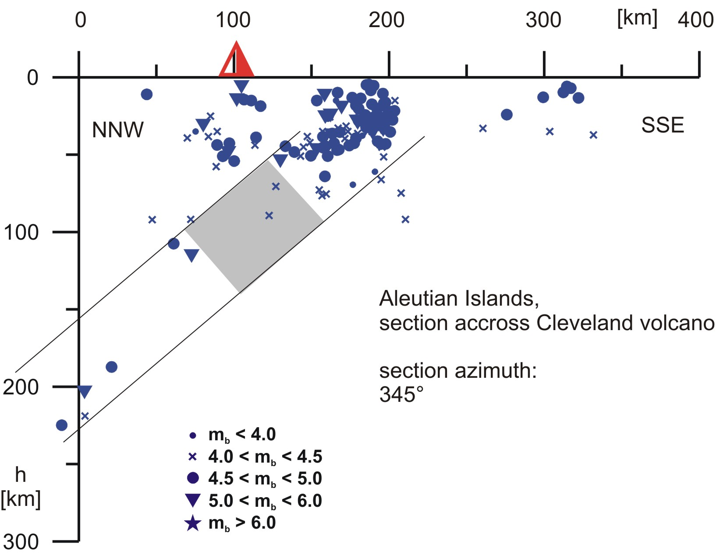
Fig.1. Distribution of earthquakes beneath Cleveland volcano (symbols of earthquakes according to ISC magnitude – see inset). Vertical cross-section perpendicular to the trench gives the depth distribution of earthquake foci in relation to the position of the trench; h is depth, Wadati-Benioff zone is denoted by parallel lines; intermediate-depth aseismic gap is shaded

absence of strong earthquakes (with m_{b}>4.0) indicates a significant change in the mechanical properties of the subducting slab at intermediate depths. All active calc-alkaline volcanoes in the investigated regions are located above this gap. (2) Clusters of earthquakes were found beneath some of the active volcanoes (e.g. Korovin, Cleveland, Makushin) of the investigated regions in the lithospheric wedge above the slab and identified as seismically active columns (Fig.1). These clusters occur only beneath the volcanoes that are located at the outcrops of seismically active fracture zones. We interpret the earthquakes in these clusters beneath volcanoes as events induced by magma transport through the medium of the lithospheric wedge that has been subcritically pre-stressed by the process of plate convergence. (3) No seismically active columns were observed beneath volcanoes that are not located at the outcrop of any seismically active fracture zone. (4) Earthquakes delineated parallel to the trench in the distance 100-200 km from the outcrop of the Wadati-Benioff zone oceanwords (Fig.2) point to intensive fracturing of the oceanic plate possibly related to the beginning of a new subduction cycle.

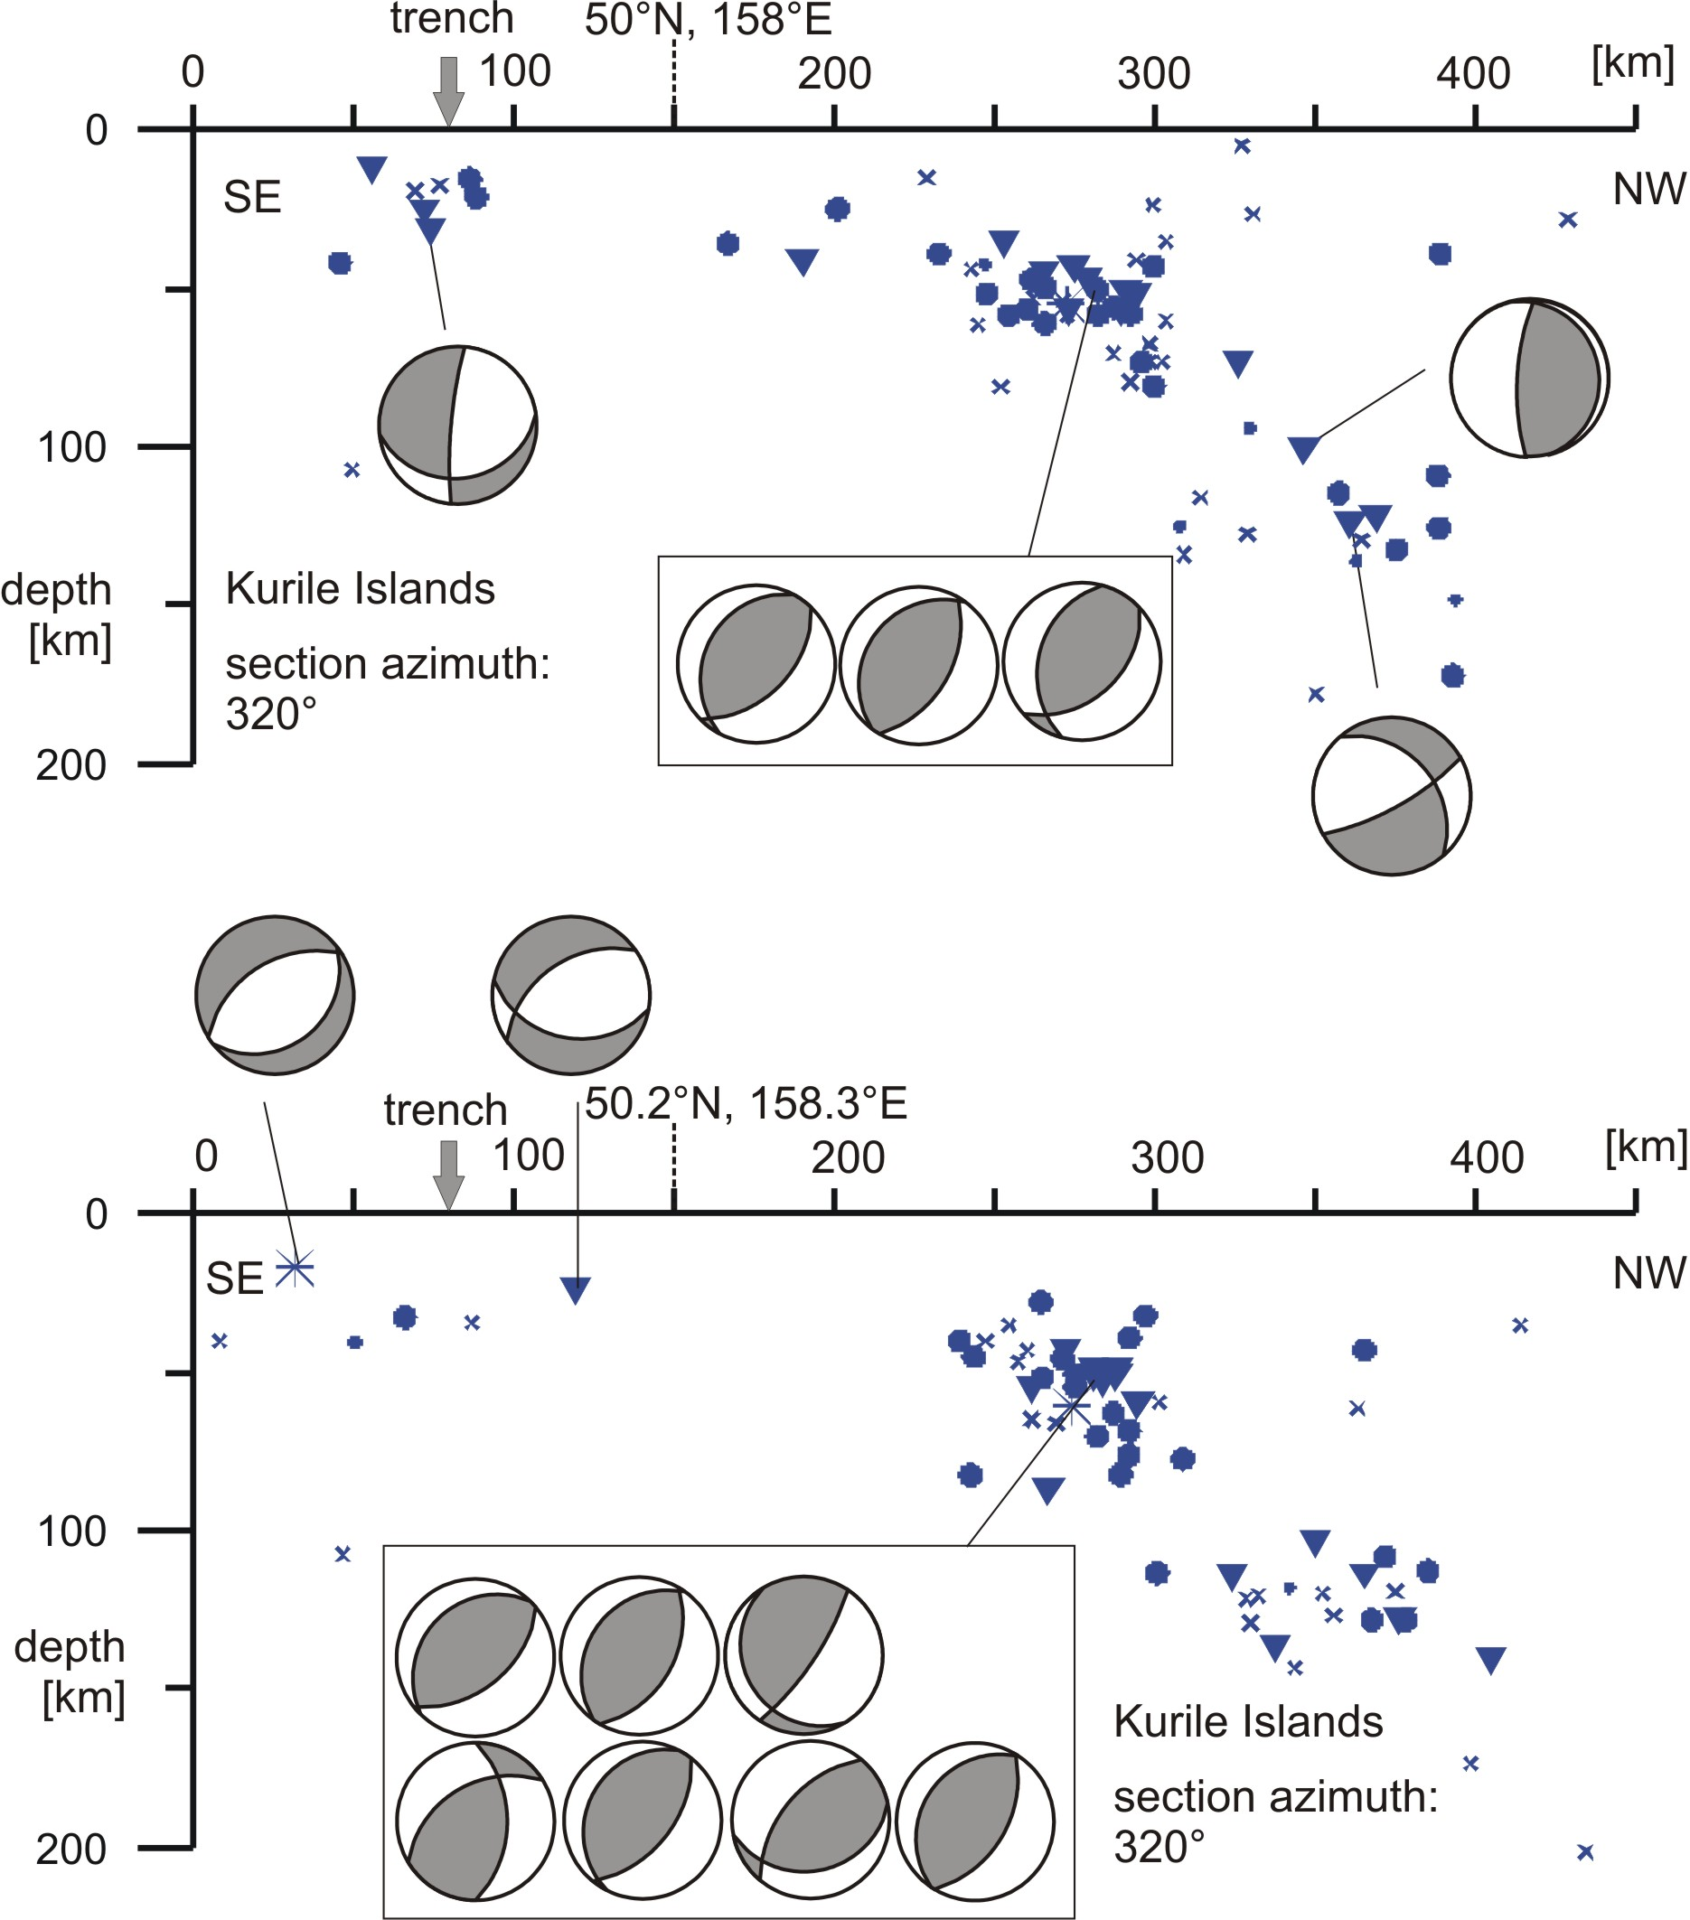

Fig.2. Distribution of earthquakes beneath the Kurile Islands (for symbols of earthquakes see Fig. 1) pointing to the existence of intensive seismicity in the distance of 100-150 km in front of the onset of the Wadati-Benoff zone

References

- Engdahl, E., R., van der Hilst, R., D. and Buland, R., 1998. Global teleseismic earthquake relocation with improved travel times and procedures for depth determinations. Bull. Seism. Soc. Amer., 88: 722-743.
- Hanuš, V. and Vaněk, J., 1984. Earthquake distribution and volcanism in Kamchatka, Kurile Islands, and Hokkaido. Part 2: Central Kurile Islands. Studia Geophys. et Geod., 28: 129-148.
- Hanuš, V. and Vaněk, J., 1991: Paleoplates buried in the upper mantle and the cyclic character of subduction. J. Geodynamics, 13: 29-45.
- Regional Catalogue of Earthquakes (1964-1999). International Seismological Centre, Edinburgh and Newbury.
- Špičák, A., Hanuš, V., Vaněk, J., 2002. Seismic activity around and under Krakatau volcano, Sunda Arc: constraints to the source region of island arc volcanics. Studia Geophysica et Geodaetica 46, 545-565.
- Špičák, A., Hanuš, V., Vaněk, J., 2004. Seismicity pattern: an indicator of source region of volcanism at convergent plate margins. Physics of the Earth and Planetary Interiors 141, 303-326.

