ROTATIONAL CONCEPT FOR THE DEVELOPMENT OF THE WESTERN-PACIFIC TRANSITIONAL ZONE IN CENOZOIC

A.V. Koloskov, G.I. Anosov

Institute of Volcanology and Seismology FED RAS, Petropavlovsk-Kamchatsky, Russia

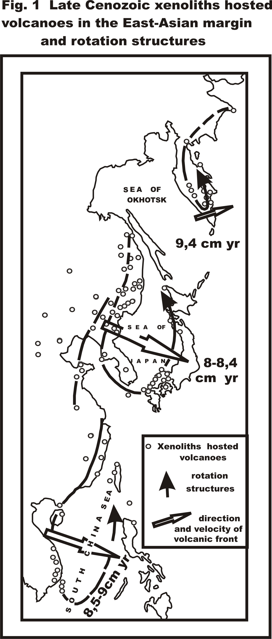
The existing geological data (Mossakovsky et al., 1998) suggest a considerably ancient (Upper Jurassic-Early Cretaceous) time of origin and relatively stable position of the Western-Pacific transition zone. The Cenozoic stage of the zone’s evolution is the best studied one. However, within the plate tectonics framework, present models of zone formation conflict with available data on geophysical field structures (Anosov et al., 2004) and heat flow anomalies (Ilyichev and Shevaldin, 1986). Manifestations of intra-platform volcanism within the boundary of insular-arc systems also do not agree within the framework of existing models. It has been necessary to introduce a new term, «slab window», in order to explain this paradoxical phenomenon. In the present compilation, authors make an attempt to explain number of characteristic features of the Western-Pacific transition zone based on a rotational geodynamics concept. Xenolith-hosting volcanites of Upper Miocene to present age were used as indicators for detection of rotational structures. The temporal succession of volcanic rocks combined with observed spatial patterns of basalt and xenolith compositions could be explained by presence of three rotational structures of cyclonic type (Figure 1). These structures have similar morphological and geological compositions. It is noteworthy that two of them delineate the marginal seas (the Sea of Japan and the South Chinese Sea) where abyssal basins are typical. The third, the Central-Kamchatskaya depression is part of the Kamchatkan structure and has inherited characteristics of Upper Cretaceous-Paleogenic continental margin basin. The western branch of each structure is characterized by wide development of intra-platform volcanism (or «sub intra-platform volcanism» for Kamchatka) with associated xenoliths of the spinel–lherzolite type. The eastern branch presents manifestation of insular-arc volcanites occasionally hosting xenoliths characterized by conditions of olivine-plagioclase equilibrium. Gradual alteration of volcanic rock compositions in macro- as well as microelements is observed along each rotational structure. That means slackening of intra-platform features and increase of insular-arc ones. By using known age determinations, it was possible to calculate average formation time of these structures as a displacement of volcanic front. As one can see in the figure, the movement corresponds to the known speeds of lithospheric plate in the region but with opposite direction. As to the geodynamic aspect, the studied structures have «asthenospheric roots». Therefore, the observed regularities can be considered within the framework of differentially rotating geospheres between which a «lubricating layer» of asthenosphere is located (Bobryakov et al., 1983; Kropotkin, Efremov, 1992; Myasnikov, Fadeev, 1979). The hydrodynamics of this layer can be described well by the theory of a spherical bearing (Loitsyanskiy, 1955). It is known that in meteorology and oceanology, these methods are used for analysing synoptic vortexes and rotational currents.

