THE PLATE SUBDUCTION UNDER KAMCHATKA: «SEISMIC» SPEED, SLOW EVENTS, DEFORMATION VELOCITY

E.I. Gordeev¹, V.M. Pavlov², V.E. Levin², V.F. Bakhtiarov²
¹Institute volcanology and seismology FED RAS, Russia
²Kamchatka Experimental and Methodical Seismological Department GS RAS,
Petropavlovsk-Kamchatsky, Russia

Some results concerning subduction process of the Pacific plate under Kamchatka and related phenomena are presented.
Estimates of seismic component of the velocity V of the subducting plate by CMT mechanisms and series of great earthquake in Kamchatka are obtained.
The interface boundary between subducting plate and Kamchatka (the continental plate) at depths 30-70 km is supposed to be a rectangle with strike 37°+180° and dip angle DIP. The rectangle location and DIP value are determined from analysis of CMT of earthquakes (1976-2003 yy) with Mw>5.5. The rectangle location is determined by CMT hypocenters cloud (DIP=25°). It turns out that the planes of CMT dipping under Kamchatka have the same dip angle 25°.
For the velocity V value we have estimates: in south zone (south of c. Shipunsky): V=0.9 cm/y; in central zone (from c. Shipunsky to c. Kronotsky): V=1.4 cm/y.
We have information about great Kamchatka earthquakes since 1737 year. In south zone there are 3 earthquakes with Mw>8.5 (moment magnitude estimates by (Gusev, Shumilina, 2004)). In central zone there are 2 earthquakes.
We suppose that after an earthquake like the Kamchatka earthquake 1952 (Mw=9.0) the seismic slip deficit is realized completely. So that we estimate the velocity V by pairs of great earthquakes.
We suppose that the source of a great earthquake occupies the whole interface zone with area S. If M0 is the scalar seismic moment of an earthquake then the slip value equals to D=M0/(μS) (μ is the shear module). Seismic component of the velocity of the subducting plate is determined by the formula: V=D/T, where T is the interval between to successive earthquake. As a result we obtain: in south zone V=6.6-7.1 cm/y (by two pairs); in central zone V=6.6 cm/y. As the oceanic plate moves with the velocity 8 cm/y, aseismic movement of the subducting plate has about 10% of the total velocity. Because of some uncertainties that attend the estimations, the final quantity of the aseismic velocity is 5-15%.
Slow preseismic movements in Kamchatka were found by GPS observations before Kronotsky earthquake (5 Dec. 1997, Mw=7.8) (Gordeev et. al.). In this study we divide preseismic period of five days before the main shock into two intervals (Fig. 1). For each interval an extended source is determine which interpreted as a slow event. We use a model souce in the form of a rectangular shear dislocation. As displacement jumps for these intervals have opposite signs, the corresponding mechanisms are opposite (Fig.1). The sources are located in the vicinity of the main shock region. They show opposite in sign movements indicating the complicated nature of the preseismic movements. Since all GPS stations are situated in the far field of the sources region other solutions are possible. So the interpretation is not unique.
To estimate the deformation velocity of Kamchatka caused by the moving oceanic plate we consider GPS observations over the period 1997-2003 yy. The component of displacement along the plate movement direction was considered. The average velocities of displacements (with respect to PETP) and variations of the velocities about averages are determined (Fig.2). Velocities are determined by linear regression in a moving window of a certain duration.

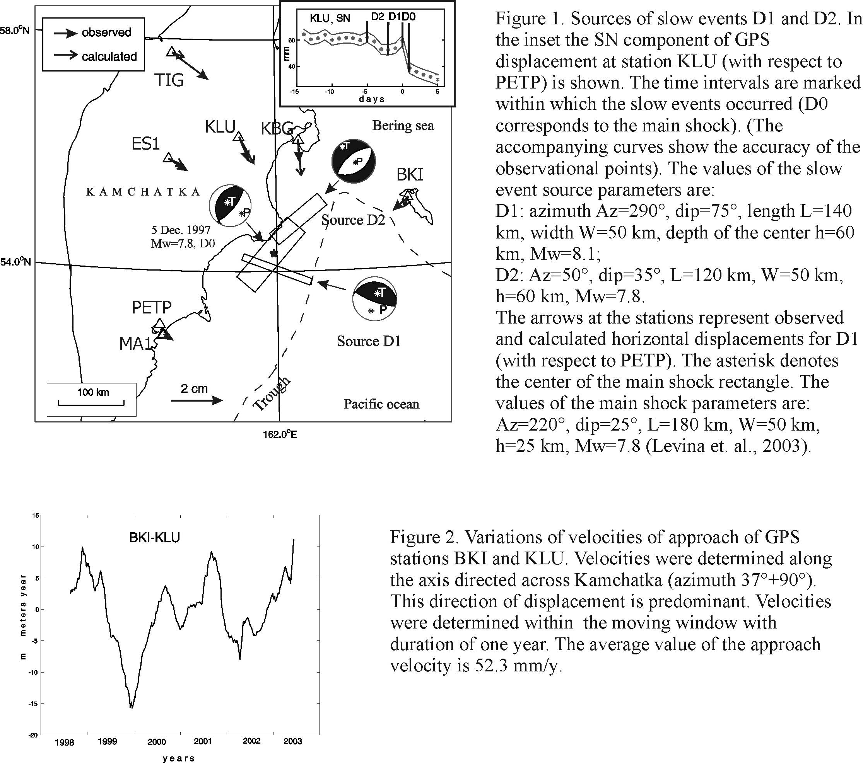

References

- Gusev A.A., Shumilina L.S., 2004. Recurrence of Kamchatka strong earthquakes on a scale of moment magnitudes. Fizika Zemli, № 3, pp 34-42.
- Gordeev E.I., Gusev A.A., Levin V.E., Bakhtiarov V.F., Pavlov V.M., Chebrov V.N., Kasahara M., 2001. Preliminary analysis of deformation at the Eurasia-Pacific-North America plate junction from GPS data. Geophys. J. Int., V. 147, pp 189-198.
- Левина В.И., Гусев А.А., Павлов В.М., Иванова Е.И., Левин В.Е., Рябинин Г.В. Хаткевич Ю.М., Гусева Е.М., Салтыков В.А., Зобин В.М. 2003. Кроноцкое землетрясение 5 декабря 1997 года с Mw=7,8, I0=8 (Камчатка). Землетрясения Северной Евразии в 1997 году, Обнинск, сс. 251-271
- Levina V.I., Gusev A.A. , Pavlov V.M., Ivanova E.I., Levin V.E., Ryabinin U.M., Khatkevich U.M., Guseva E.M., Saltykov V.A., Zobin V.M., 2003. Kronotsky earthquake 5 Dec. 1997, Mw=7.8, I0=8 (Kamchatka), Earthquakes of North Eurasia in 1997 year, Obninsk, pp. 251-271.

