1817 INTRACALDERA ERUPTION OF OKMOK VOLCANO, ALASKA: TRANSITION FROM HYDROMAGMATIC TO STROMBOLIAN ACTIVITY

Christina Neal¹, Jim Beget²
¹ U.S. Geological Survey, AVO, 4200 University Drive, Anchorage, Alaska 99508, USA. E-mail: tneal@usgs.gov
² Department of Geology, University of Alaska, Fairbanks, Fairbanks, AK 99775, USA. E-mail: Ffjeb1@aurora.uaf.edu

Okmok Volcano consists of a 10-km-diameter, late-Holocene caldera on Umnak Island in the eastern Aleutians, 1400 km southwest of Anchorage (Byers, 1959). The most recent eruption in 1997 (Patrick et. al, 2003) was predominantly strombolian in character, producing a basaltic-andesite lava flow within the caldera and a localized scoria and ash fall. Recent geologic mapping has confirmed, however, that since caldera-formation ~2050 ¹⁴C yrs BP (Beget and Larson, 2001), far more violent eruptions from vents within the caldera have impacted all flanks of the volcano with tephra fall, ballistics, pyroclastic surges and flows, and lahars. An example of these is the 1817 eruption. Reevaluation of the historical and geological record suggest that this event included opening hydrovolcanic activity that produced significant pyroclastic fall and surge deposits extending down the north and east flanks of the volcano. Later stages of this eruption involved strombolian lava fountaining and production of several lava flows. 1817 vents form a 4-km-long arc that parallels the base of the north caldera wall and include a 50-70-m-deep, elongate maar crater that excavated pre-existing tuff cone deposits. Terrace morphology and flood deposits less than 200 ¹⁴C yrs BP indicate a related flooding event down Crater Creek that drains the caldera, consistent with historical accounts of Aleut village inundation at the coastline in 1817 (Wolfe, 2001). The later part of the eruption produced a 120-m high cinder and spatter cone and a blocky 'a'a lava flow field that fills a shallow basin near the Crater Creek outlet. These results indicate that Okmok is capable of eruptions far more violent than the largely effusive events of the last century (Grey, 2003), especially if future eruptive activity occurs in the northeastern part of the caldera where shallow groundwater and a shallow lake persist.

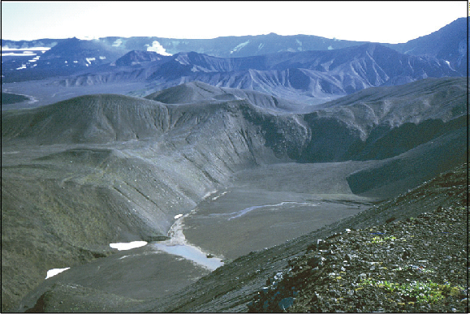 View looking SW across 1817 maar crater of Okmok Volcano. Tuff cones formed during the high stand of the post-caldera «Crater Lake» - between ~1000-2000 years BP - are in the distance. The 1817 maar is elliptical and may consist of several coalesced craters. Short and long axes measure ~400-500 and 1000-1200 m, depth ranges from 60-130 m. Post-maar spatter cones and agglutinate are largely buried by alluvium.

References

- Beget, J., and Larsen, J.F., 2001. Links between pre-historic, high-latitude volcanic eruptions, aerosol events in the GISP2 ice core, Roman records, and Holocene climate change: International Geosphere-Biosphere Program, Amsterdam, NL, Abstract Volume p. 185.
- Byers, F. M. Jr., 1959, Geology of Umnak and Bogoslof Islands, Aleutian Islands, Alaska: Investigations of Alaskan Volcanoes, U.S. Geological Survey Bulletin B 1028-L, p. 267-369, 5 map sheets, various scales.
- Grey, D. M., 2003, Post caldera eruptions at Okmok Volcano, Umnak Island, Alaska, with emphasis on recent eruptions from Cone A: University of Alaska Fairbanks unpub. M.S. thesis, 135 p.
- Patrick, M.R., Dehn, J., Papp, K.R., Lu, Z., Kean, K., Moxey, L., Izbekov, P., and Guritz, R., 2003, The 1997 eruption of Okmok Volcano, Alaska: a synthesis of remotely sensed imagery: Journal of Volcanology and Geothermal Research, v. 127, p. 87-105.
- Wolfe, B. A., 2001, Paleohydrology of a catastrophic flood release from Okmok caldera and post-flood eruption history at Okmok Volcano, Umnak Island, Alaska: University of Alaska Fairbanks unpub. M.S. thesis, 100 p.

