RECENT VOLCANIC ACTIVITY IN HOKKAIDO, JAPAN AND MONITORING BY SAPPORO DMO, JMA

Jun’ichi Miyamura
Volcanic Observation and Information Center, Sapporo District Meteolorogical Observatory, Japan Meteorological Agency, Japan

There are 18 active volcanoes in Hokkaido, Japan. In march 2002, Volcanic Observation and Information Center (VOIC) was established in Sapporo District Meteorological Observation and 5 more active volcanoes, i.e. Meakandake, Tokachidake, Tarumaesan, Usuzan and Hokkaido-Komagatake are placed under constant watch with real time telemetered data of seismic, geodetic, infrasonic and visual observations by Sapporo VOIC.
Mobile volcano observation team of Sapporo VOIC periodically conducts inspection of activity by field observation (geodetic survey with GPS, geomagnetic survey with proton geomagnetometer and geothermal survey).
Sapporo VOIC issues volcanic information (volcanic alert, volcanic advisory, volcanic observation report and volcanic regular bulletin) to the disaster prevention authorities and to the public.
In this presentation, we will introduce our monitoring system and report recent volcanic activity in Hokkaido based on various observation.
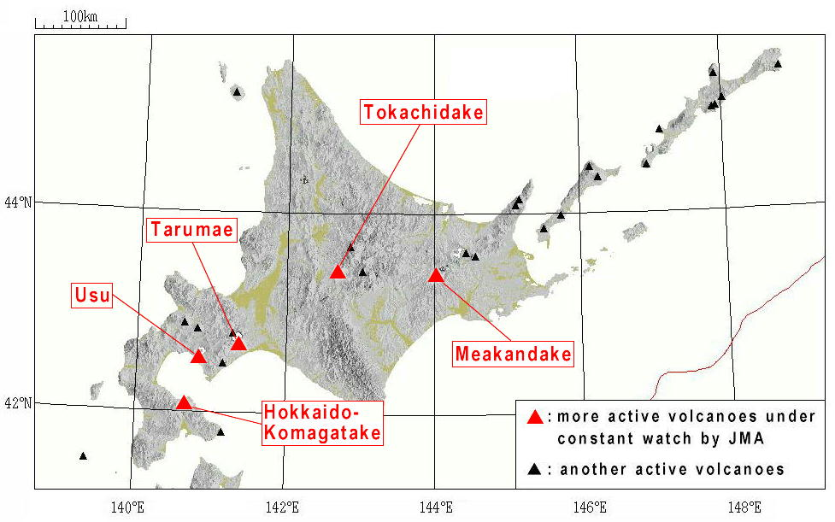 Fig.1 Distribution of active volcanoes in Hokkaido and southern Kurile

