VOLCANIC TREMOR AND ITS USE IN ESTIMATING ERUPTION PARAMETERS

Stephen R. McNutt
Alaska Volcano Observatory, Geophysical Institute UAF, Fairbanks, AK 99775 USA

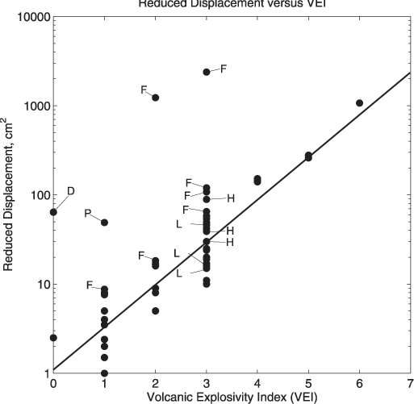
Volcanic tremor, a continuous seismic signal, accompanies virtually all eruptions. Several published studies have examined relations between tremor reduced displacement (DR, a normalized amplitude measure) and the VEI or ash plume height. The goals of these studies are to determine the physical relationships between tremor and eruptions and to use DR values to provide real-time estimates of eruption parameters. This study examines tremor for 50 eruptions from 31 volcanoes. Several trends are observed: 1) large eruptions produce stronger tremor than small ones; 2) fissure eruptions produce stronger tremor than circular vents for the same fountain height; 3) eruptions with higher gas content produce stronger tremor than those with low gas content; and 4) phreatic eruptions produce stronger tremor than magmatic eruptions for the same VEI. Using tremor DR to estimate eruption parameters is a statistical problem with several factors contributing to uncertainties. First, tremor occurs when volcanoes do not erupt as well as when they do. Based on a worldwide sample, 60-80 percent of tremor episodes accompany eruptions, while 20-40 percent do not. Thus there is a significant chance that no eruption is occurring. Second, for each VEI, there is a range of DR, so it is possible to overestimate or underestimate the VEI. Hence there will always be a false alarm rate (~10 percent). Improvements can be made in the estimates if the types of eruptions, shapes of vents, and gas contents are known. These can be estimated from previous eruptions or measured near-real-time from independent data. However, adding additional information takes time, delaying forecasts. A primary benefit of seismic data is that it is real-time, it is not affected by darkness, and is usable during poor weather, although the signal-to-noise ratio can be worsened. Monitoring tremor DR is an effective way to characterize eruptions in progress.

Figure 1. Reduced displacement, a normalized measure of amplitude, versus the Volcanic Explosivity Index for 50 eruptions at 31 volcanoes. The regression line is from McNutt (1994) based on a smaller data set and is shown for comparison. Fissure eruptions are labeled F; a phreatic eruption is labeled P; deep (40 km) tremor from Kilauea is labeled D; and three pairs of values from eruptions with high and low gas content are labeled H and L respectively.

