⁴⁰AR/³⁹AR GEOCHRONOLOGY OF KHAPITSA PLATEAU AND STUDYONAYA RIVER BASALTS AND BASALTIC ANDESITES IN CENTRAL KAMCHATKA DEPRESSION, KAMCHATKA, RUSSIA

Julie A Calkins

New Mexico Institute of Mining and Technology, 801 Leroy Place, Socorro, New Mexico 87801

High-precision ⁴⁰Ar/³⁹Ar age spectra have been obtained from 12 groundmass concentrate samples representative of 7 plateau-forming basalt and basaltic andesite units in the Khapitsa Plateau and the Studyonaya River within the Central Kamchatka Depression (CKD). The CKD is a 200 km wide intra-arc depression (graben) structure bounded by major faults to the east with its western flank gradually ascending towards the crest of the Sredinny Range (Kozhurin, 2004; Tibaldi, 2004). The origin of the depression is poorly understood but maybe related to

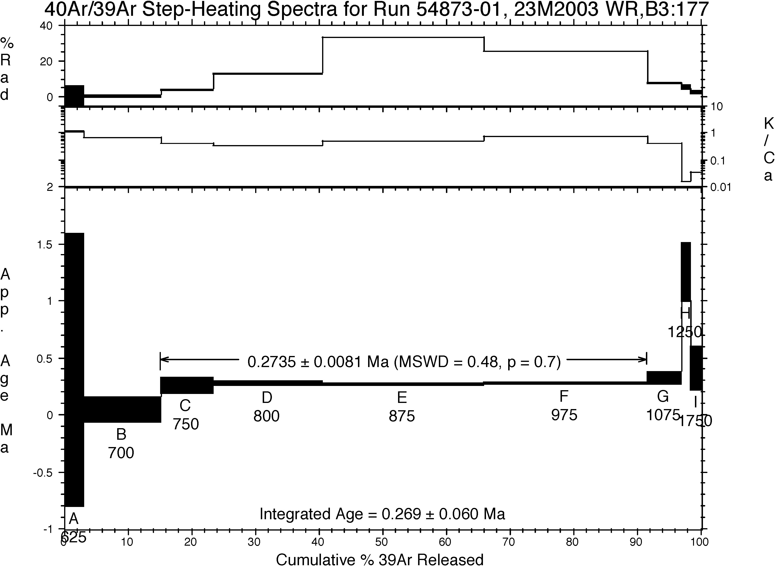

Fig.1. Age spectra for a representative Khapitsa Plateau basalt with plateau age of 274 + 8 ka.*

subduction of the Emperor Seamounts chain (Churikova, Dorendorf et al., 2001). Plateau lavas are voluminous and widespread in the CKD, recording the onset of extension. They are overlain by younger volcanic rocks of the Kliuchevskoi group which contains some of the most productive arc volcanoes in the world. The ages of the plateau lavas presented here document some of the oldest known volcanism in the CKD and provide temporal constraints on faulting along the eastern margin of the depression. ⁴⁰Ar/³⁹Ar analyses of Khapitsa Plateau basalts, which are uplifted on the flank of the Kumroch Range and cut by faults bounding the CKD, have an eruption age of 274 + 8 ka (2σ) (Fig. 1). Replicate ⁴⁰Ar/³⁹Ar plateau age determinations for 3 different samples agree within analytical error. Studyonaya River basalts and basaltic andesites occur in the center of the CKD, north of Tobalchik volcano and document late-Pleistocene eruptions ranging in age from 262 ka to 25 ka (Fig. 2). Ages of these previously undated plateau lavas record the continued process of intra-arc extension throughout the late-Pleistocene.

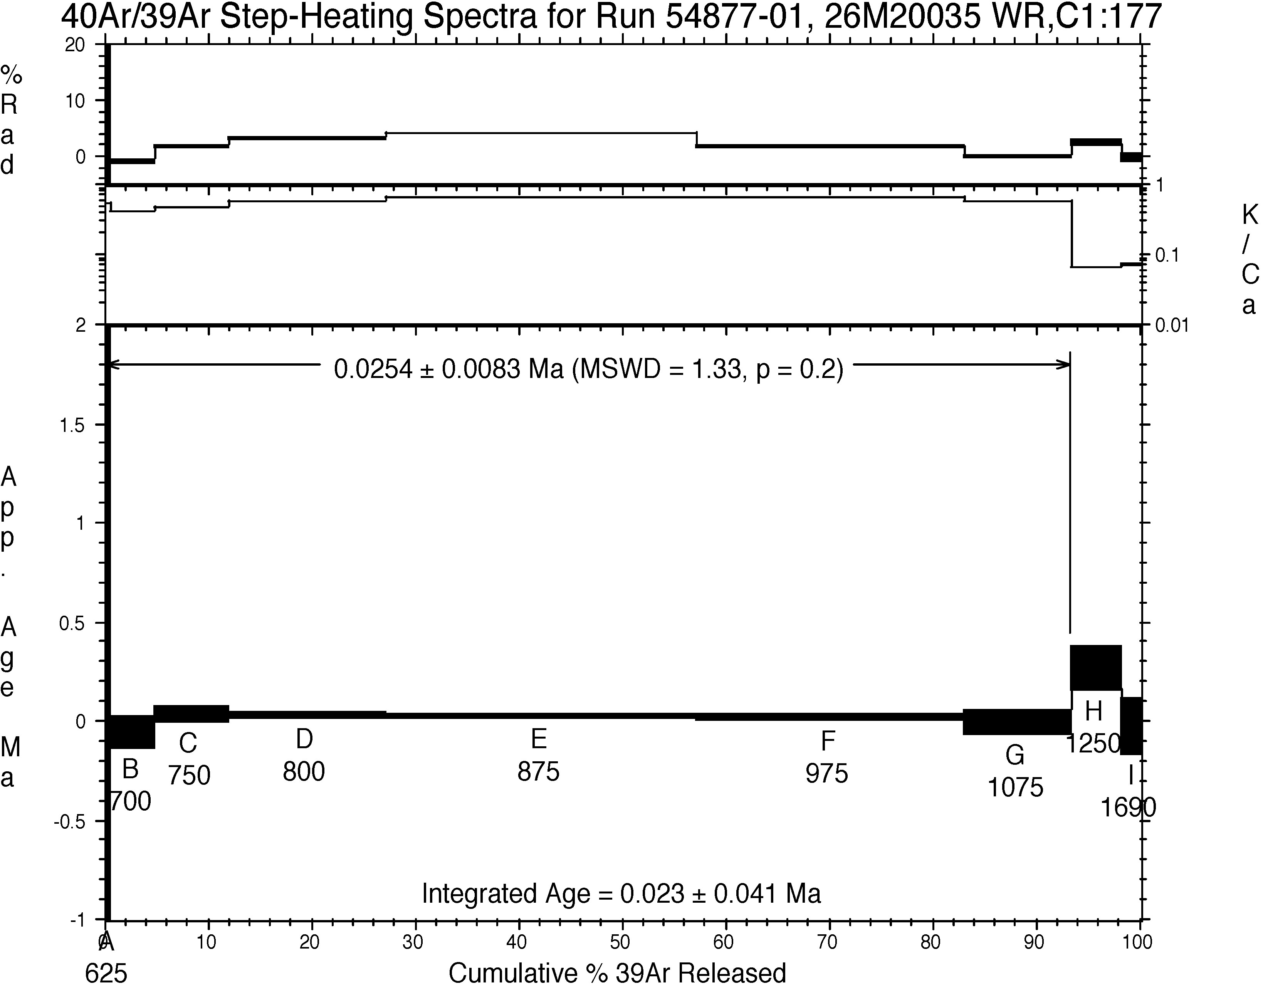

Fig.2. Age spectra for a Studyonaya River basalt with plateau age of 25 + 3 ka.*

*Groundmass concentrates were heated in a furnace over 9 temperature intervals. Plateau ages were defined from age spectra if the fractions consisted of 2 or more contiguous incremental heating steps, yielding more than 50% of the ³⁹Ar, which are statistically indistinguishable at the 95% confidence interval.

References

- Churikova, T., Dorendorf, F., and Worner, G. (2001). Journal of Petrology 42(8): 1567-1593.
- Kozhurin, A. (2004). Tectonophysics 380: 273-285.
- Tibaldi, A. (2004). Eos 85(14): 133, 136,141.

