ORDER CLUSTERING IN THE SEQUENCES OF VOLCANIC ERUPTIONS AND EARTHQUAKES OF THE WORLD

Alexander A. Gusev
Institute of Volcanology and Seismology, Petropavlovsk-Kamchatsky, Russia.
E-mail: gusev@emsd.iks.ru

Any time-ordered list of events of variable size or «weight» can manifest order clustering, or an inherent tendency of the largest events of such a list to occur «too often» as close neighbors in the list; i.e. significantly more often than should be in a similar randomly-shuffled event list. Accurate timing is irrelevant for order clustering, in contrast to «common» clustering when events (whose size is inessential) occur as tight, compact temporal groups or bursts. Recently, order clustering was revealed for the sequence of Holocene volcanic eruptions on Kamchatka. (Gusev a. o. 2002). In this study I look for order clustering behavior in global volcanic data sets. I analyzed the global catalogue of volcanic eruptions kindly provided by Lee Siebert (Siebert&Simkin 2002, labeled SMI). The most reliable and uniformly reported part of this catalogue is that with VEI≥3 in 1960-2002. Order clustering is present here, with the statistical significance level Q=5%. Unexpectedly, common clustering (i.e., the formation of tight temporal groups) is absent for this data subset. However, common clustering was found for other subsets of the same catalog: with VEI≥4 in 1800-2002, Q=5%; and VEI≥6 in -2000-2002, Q=5%.
Another data set pertinent to global volcanic activity was analyzed, that of the time history of the «ice core volcanic index» IVI (Robock 2000) kindly provided by Alan Robock. I analyzed the uniform subset of these data, with IVI>0.03, for 1400-1985, and within this subcatalogue, only the inter-event time intervals that are longer than 3 yr., i.e., longer than the settling time of the stratospheric aerosol. The analysis showed significant order clustering (Q>5%); common clustering is also present and significant. Clustering of volcanic sequences is of multiscaled kind, and the data can be viewed at as flicker-noise pulse sequences.

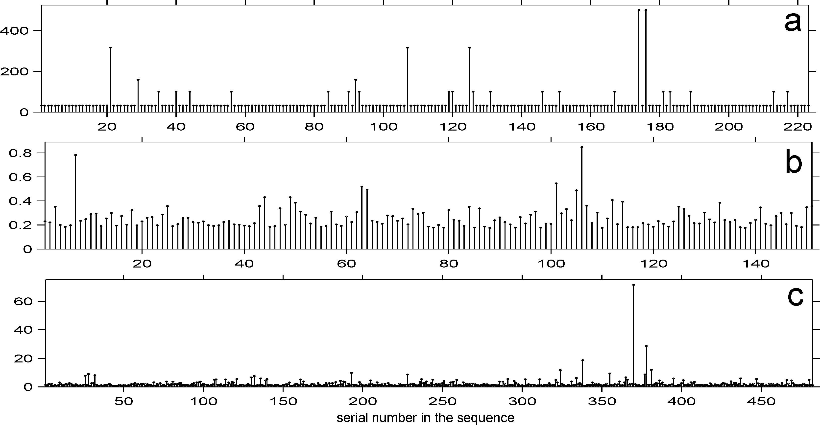

Figure 1. Three global event sequences. (a) Eruptions from the SMI catalogue for 1960-2002, VEI≥3. (b) Non-zero IVI indices for 1400-1985, data of two hemispheres combined, IVI>0.03. (c) Earthquakes of the ABE catalogue for 1900-1989, M_{s}≥7.2. Abscissa: the number of an event in the list; ordinate: square root of the size parameter: 10^{VEI+2} for (a), IVI for (b) and M_{o} in 10²⁷ dyne⋅cm units for (c). Square root is used to make the diagram more legible. A clear tendency is seen for greatest events to appear in clusters or bursts. Note that common clustering, i.e. the tendency to form tight temporal groups, in no case can show itself on a diagram of the presented kind, because there is no time reference at all on these plots.

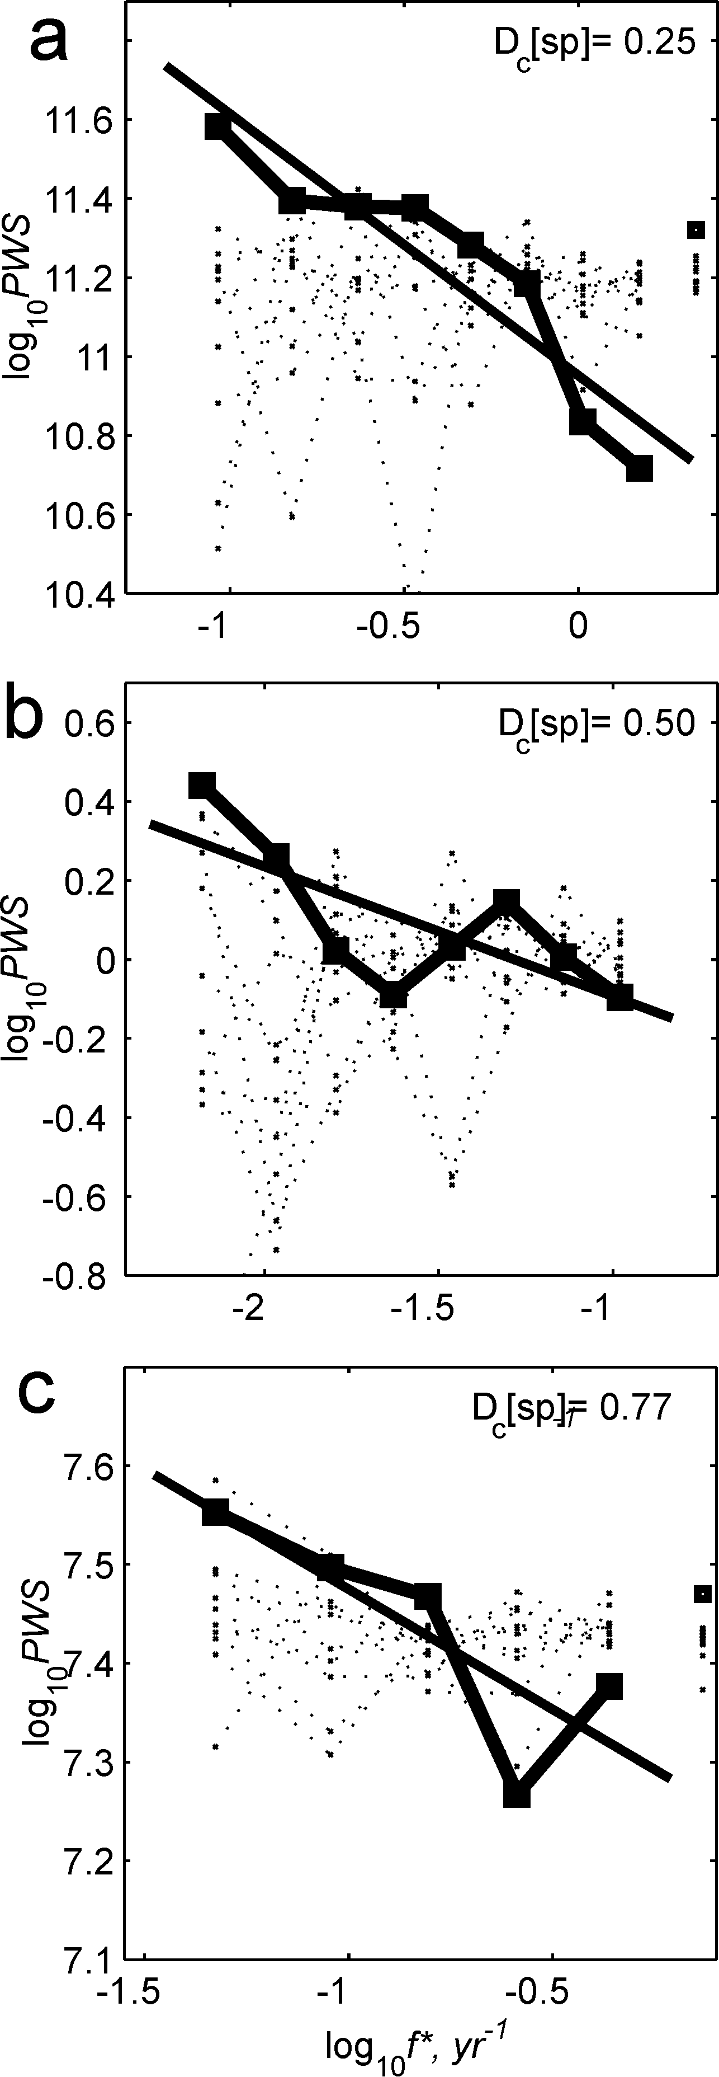 | Figure 2. Power spectra (a, b and c) of the three sequences a, b and c of Fig. 1, respectively (kinked lines with squares). Abscissa: logarithm of «frequency», i.e. of the argument of Fourier transform of a sequence of Fig.1 (rescaled so as to approximate real frequency). Ordinate: logarithm of the power spectrum density of the original sequence, averaged over a frequency band of the constant logarithmic width, equal to 0.15 (≈7 points per decade). Assume order clustering to be absent and events to occur in a purely random order. When the amount of data is very large, the graph of power spectrum must be a horizontal line («white noise»). With limited data volume and no clustering, observed spectrum must oscillate around a horizontal line. Such a behavior is illustrated by thin dotted lines that depict the spectra of ten randomly shuffled versions of a corresponding original sequence. The difference with the plot constructed from the real data is evident. The straight lines (drawn using least squares) approximate the observed spectral points. The slope of such a line provides the estimate of the exponent of the power law of the spectrum. The power-law appearance of spectra («flicker-noise behavior») suggests self-similar, fractal character of the sequences. The exponent of the power law can be used to determine correlation dimension D_{c} of the sequence. The thus obtained estimates of D_{c} are given on each plot. I estimated D_{c} via correlation integral as well. With limited data volume, the accuracy of the estimates is low. Nevertheless, the hypothesis D_{c} <1 has been confirmed statistically, at 5% significance level, in each of the three cases, thus verifying the presence of order clustering.
Order clustering is present also in the global earthquake sequence (Ogata&Abe 1991). We confirmed this result analyzing two global earthquake lists: for 1900-1989 (Abe 1981, augmented, labeled ABE) and for 1977-2000 (Harvard CMT, labeled HRV), with significance levels of 1% and 5-10%. The primitive kind of common clustering, related to aftershocks, was effectively suppressed before any analysis of these data. Unexpectedly, a scale dependence of clustering was revealed in global earthquake catalogs with excluded aftershocks. Whereas a clear clustering behavior of multi-scaled (fractal) kind is observed for long time delays, it was suppressed at short time intervals, (<5 yr for ABE and <0.5 yr for HRV), and even some indications of temporary quiescence surrounding the greatest events were found.
This study was supported by RFBR, grant 03-05-64459.
References
- Abe K. (1981) Phys. Earth Planet. Interiors. 27, 72-92.
- Gusev, A.A., Ponomareva, V.V., Braitseva, O.A., Melekestsev, I.V. and Sulerzhitsky, L.D. (2003). J. Geophys. Res. 108, 2126.
- Ogata, Y. and K.Abe. (1991). Int. Statist. Rev., 59, 139-161.
- Robock, A. (2000). Rev. Geophys., 38, 191–219.
- Siebert, L., T. Simkin (2002-). Volcanoes of the orld...(http://www.volcano.si.edu/gvp/world/).

