AVACHINSKY VOLCANO GEOTHERMAL RESERVOIR BASED ON FUMAROLES ACTIVITY AND SEISMOLOGICAL NETWORK DATA

V.A. Droznin, I.K. Dubrovskaya, A.V. Kiryukhin, E.V. Chernykh, S.L. Senyukov,
G.O. Ivanysko
Institute of Volcanology FEB RAS, Piip-9, Petropavlovsk-Kamchatsky, Russia, 683006

Avacinsky volcano (Fig. 1) eruptions are hazardous for the 250,000 people of Petropavlovsk-Kamchatsky, Russia, which located 25 km from this volcano. Cone of the volcano was created 3500 years ago and erupted 15 times since 1737 with an average mass rate estimated as 150 kg/s (Melekestsev, 1994). The last eruptions included a lava plug overlay of the 300 m wide and 200 m deep crater of the Avachinsky volcano cone (1991) and a fracturing and steam explosion in the lava plug associated with an earthquake swarm (2001).
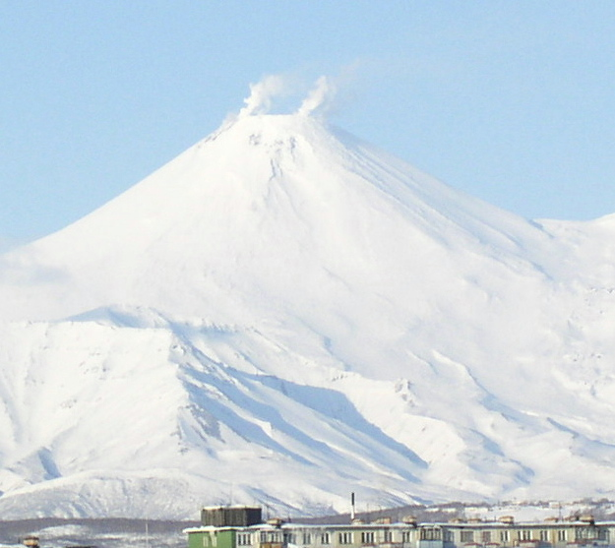

Fig.1 Avachinsky volcano 24.03.2004.

The most prominent fumaroles in the crater before 1991 were: Step Point, Sulfur Ridge, Small Sulfur, the Bottom fumaroles, the East fumaroles and the NE fumaroles (Fedotov et al, 1977). While the crater was filled with lava during the eruption (14.01.91), fumaroles activity maintained. Since current locations of the fumaroles are coinciding with their pre-eruption locations, it may be concluded that the steam and magma phases occur in independent reservoirs. Nevertheless, the heat anomaly detected by an infrared survey (1988) pointed out the place of the magma outflow during the next eruption in 1991.
The heat discharge of the fumaroles may be estimated based on the geometrical characteristics of their clouds, taking into account local meteorological conditions (S.A. Fedotov, 1982, V.V. Ivanov, 1988). The Avachinsky volcano fumaroles have been monitored since 2003 for the purpose of using the size of the fumaroles clouds to estimate the corresponding heat discharge. Its worth noting, that the real size of the thermo-clouds may be estimated only when there is 100% air saturation. In the most of cases, air saturation is less than 100% and some fraction of the steam condensate transfers to the vapor phase. To correctly estimate of the thermo-clouds sizes, the wind velocity, air temperature and saturation are needed.
The October 2001 eruption revealed an active steam dominated reservoir below the lava plug of 1991. The swarm of the earthquakes hypocenters synchronized with the eruption 2001, showing the true geometrical size of the steam-dominated reservoir (Fig.2). This 1-km radius reservoir extends from the elevation of lava plug at 2750 m.a.s.l. to –1000 m.a.s.l., where some north-east trend shifting of the reservoir occurs. Similar earthquake distributions were detected in 2004.
The seismic nature of the steam producing geothermal reservoir is clearly revealed in the Kakonda geothermal field (Japan), where 80 MWe Power Plant operates. Microearthquake hypocenter distributions on Kakkonda geothermal field (Fig. 2) occur in the fractured rock of the steam producing geothermal reservoir, which was confirmed by the drilling of exploitation wells ranging in depth from –1000 м to +1000 m.a.s.l. (T. Tosha et al, 1988). Seismic activity in Kakkonda geothermal reservoir increases when reinjection events or the closing of exploitation wells for repair works took place (fluid pressure increased in both cases).

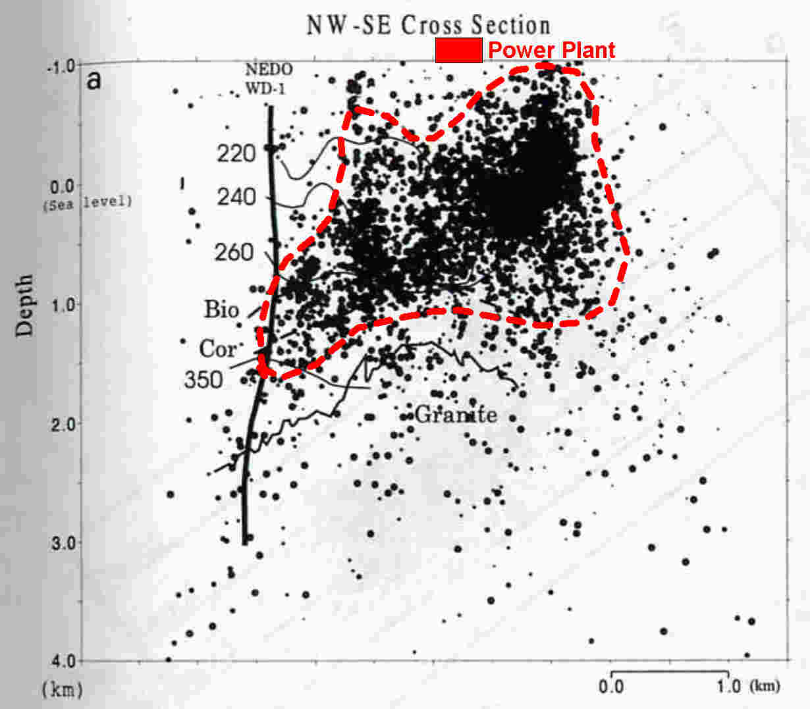
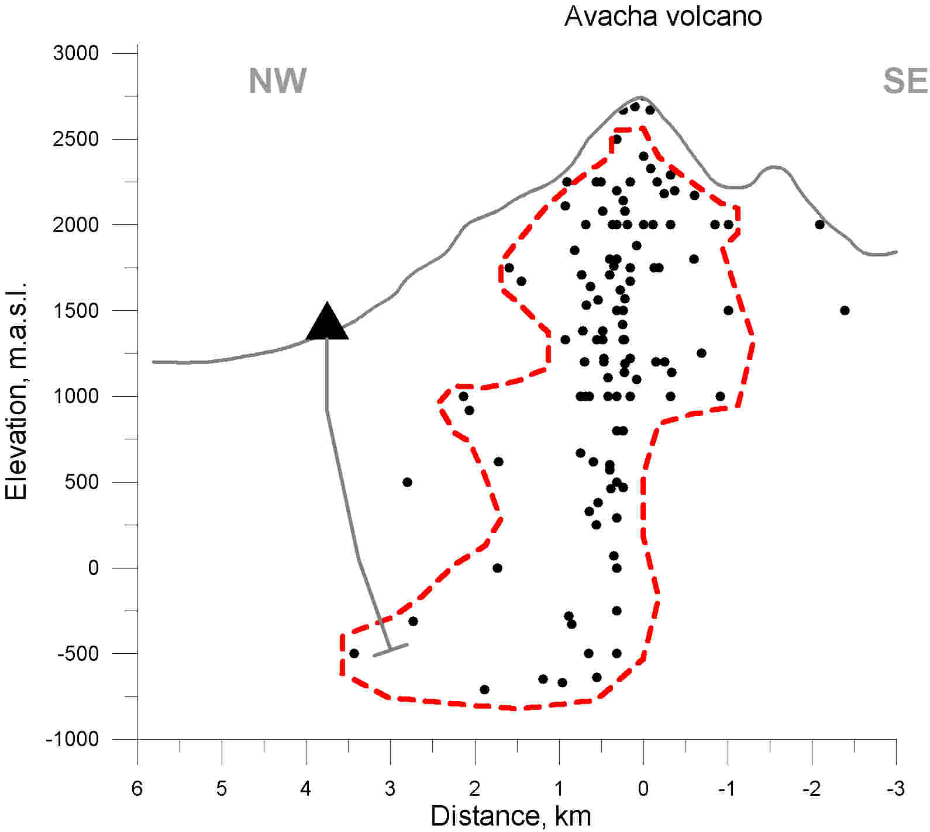

Fig.2 Boundaries of geothermal reservoirs (dashed line) in vertical cross-sections of the Avachinsky volcano Cone (Kamchatka) and Kakkonda geothermal field (Japan) (T. Tosha et al, 1988)

(Left) Vertical cross-section of the Avachinsky volcano cone: circles are earthquake hypocenters synchronized with steam eruption in 2001 (data from four stations Kamchatka EMSD GS RAS), possible drilling target also shown.
(Right) Vertical cross-section of the Kakkonda geothermal field (Japan): circles are earthquake hypocenters from 1988 (data from eight GSJ stations), counters – are temperature distributions.
3-D numerical TOUGH2V2.0(EOS3)-based model of the Avachinsky volcano cone on-going. This model targeted the assessment of thermal-hydrodynamic conditions in the cone, steam explosion condition forecasts, geothermal resource assessment, and feasibility study of the drilling project (1.5 km deep well) to supply steam for ski-resort recreation activity.
This work supported by RFBR project 03-05-65373.

References

- I.V. Melekestsev, O.A. Braitseva, V.N. Dvigalo, L.I. Bazanova Avachinsky volcano historical eruptions, Volcanology and seismology Journal, №2, 1994, p.3-24 (in Russian).
- V.V. Ivanov Clouds connected to fumaroles and volcanoes eruptions. Volcanology and seismology Journal, 1988, №4, p. 37-50 (in Russian).
- S.A. Fedotov, S.T. Balesta, V.A. Droznin, Y.P. Masurenkov, V.M. Sugrobov On possibility of the magma chamber of the Avachinsky volcano use. Bull. Volcanological stations, №53, 1977, p.27-34 (in Russian).
- S.A. Fedotov Heat discharge assessment of the fumaroles and volcano eruptions clouds based on height of the clouds, Volcanology and seismology Journal, 1982, №4, p.3-27 (in Russian)
- A.V.Kiryukhin, I.K.Dubrovskaya, N.I. Kiryukhina. Modeling study of the Avachinsky volcano cone hydrothermal eruption conditions. Abstracts Week A, XXIII General Assembly of the International Union of Geodesy and Geophysics, Sapporo, Japan, June 30,- July 11, 2003, 564 p.
- T.Tosha, M. Sugihara, Y. Nishi Revised Hypocenter Solutions for Microearthquakes in the Kakkonda Geothermal Field, Japan // Geothermics, v.227, #5-6, p.553-571.

