LOCAL CONCEPTUAL MODEL OF THE NORTH-PARAMUSHIR HYDROTHERMAL SYSTEM
(NORTH KURIL ISLAND)

Khubaeva¹, O., Boikova¹, I., Nikolaeva¹, A.
¹Institute of Volcanology and Seismology FEB RAS, Petropavlovsk-Kamchatsky, Russia

Linear faults were identified through topographic map interpretation (scale 1:50 000). The main fault system was found to be NNE trending (Belousov et al., 2002). Sub-lateral fault zones are mild in the relief, so their interpretation by topographic map is difficult. Thus, along the east coast of the island, sublatitudinal trenches system (trough valleys), which are associated with river valleys including Ptichya, Nasedkina etc. was interpreted. Further study of this data is recommended.
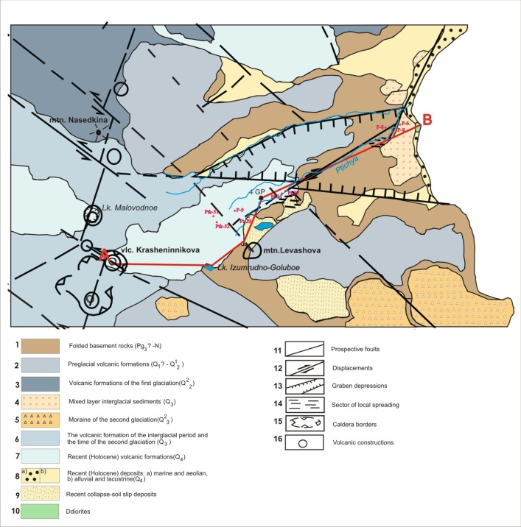

Fig. 1. Schematic geological map of the Ptichya river by Fedorchenko et al., 1989

It is generally accepted that the Ptichya river is confined to a large NW trending regional fault (Fig. 1), which is clearly manifested on the surface in the form of limonite slides, phreatic craters and phreato-magmatic explosions in addition to a shear zone in the North-East board of Izumrudno-goluboe lake, large fields of hydrothermally altered rocks and low-temperature surface manifestation. In Figure 1, line A-B was used to model a cross-section based on the 4-GP well cross-section. In the cross-section, rock units, hydrophilic formation, explosive crater, areas of hydrothermal altered rocks and low-degree hydrothermal manifestation are shown.
Geological sections of the north-eastern and northern part of the North Paramushir hydrothermal-magmatic system were studied. The eastern slope of Krasheninnikov volcano, to a depth of 1115 m (based on data from 4-GP well), was studied. Hydrothermal-metasomatic rock alteration and the chemical composition of thermal water springs of the Ptichya River were characterized. In the cross section, a succession of metasomatic zones (top – bottom): quartz – epidote – chlorite, illite-chlorite – calcite, montmorillonite – zeolite is observed. Such vertical metasomatic zonation is observed in the periphery of the main upflow zone of hydrothermal solutions, where the permeability of the rocks is low and there is an intense influx of cold meteoric water from the surface.

References

Belousov, V.I., Rychagov, S.N., Sugrobov, V.М. The North-Paramushir Hydrothermal-Magmatic System: Geological Structure, Conceptual Model, Geothermal Resources // Vulkanologiya i Seismologiya, 2002. № 1. Pp. 34-50.
Fedorchenko, V.I., Abdurakhmanov, А.I., Rodionova, R.I. Volcanism of the Kuril Island Arc: Geology and Petrogenesis. М.: Nauka, 1989. P. 238.

